FROM PRINCIPAL’S DESK
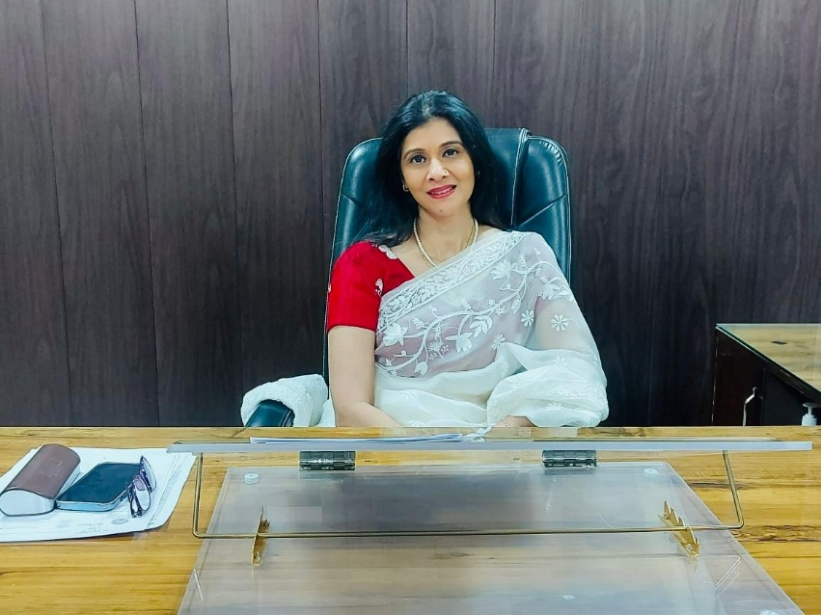
Mrs. Ritika Gupta, Principal, HES1

It gives me immense pleasure to present the Annual Report of Smt. Sushma Swaraj Government College for Girls, Ballabgarh for the academic session 2024-25. The report is a reflection of the collective efforts, achievements, and progress made by our students, faculty, and staff throughout the year.
Our institution has always been committed to nurturing young women with knowledge, confidence, and values that empower them to meet the challenges of the future. This year too, our college has excelled not only in academics but also in co-curricular and extra-curricular activities, reflecting the holistic development of our students.
I express my heartfelt appreciation to the dedicated faculty members for their tireless commitment, to the students for their enthusiasm and achievements, and to the non-teaching staff for their continuous support in the smooth functioning of the college. I also extend my gratitude to the Department of Higher Education, parents, and well-wishers for their constant encouragement and cooperation.
As we move forward, let us continue to work together with the vision of building strong, confident, and responsible women who will contribute meaningfully to society and the nation.

With best wishes,
Ritika Gupta
Principal
Smt. Sushma Swaraj Government College for Girls, Ballabgarh

ABOUT THE COLLEGE
Smt. Sushma Swaraj College began modestly in a Government school building in 2018 and relocated to its current site in Sector 2, Ballabgarh in March 2023. Within a short span of 7 years, the college has evolved significantly and is now a preferred destination for the young girls of Faridabad district seeking quality higher education.
The total area of the college campus is 6 acres with the covered area 1 lakh sq. ft. The new college building boosts of a fully air conditioned multipurpose hall, admin room, library, 3 lecture theatre and girls common room. There are 16 rooms for various cells & departments, 21 class rooms, 8 labs, 1 fully functional canteen, 1 gymnasium ground and parking space and RO- Water cooler. Washroom are available on each floor. There is sufficient furniture available in college campus to facilitate the Girls students for their proper studies. College campus is equipped with CCTV for maintaining adequate security in the college Campus and to ensure the safety of the students, their belongings, faculty and the college property. To make the college campus eco friendly number of steps have been taken in recent past. Umpteen number of plants are planted in college campus. Rain water harvesting system is functional in college campus so that under water level can be recharged frequently.
there are two Green rooms in multipurpose hall to facilitate the girl students during cultural activities.

The college initially offered undergraduate programmes in B.A., B.Com (Voc) and B.Sc. (IT). At present the college offers UG courses in BCA, BBA, B.Sc. Med. and Non-Med., B.A. and B.Com as well as PG courses in History, English, Physics, Computer science, Commerce. The college aims to create an intellectual atmosphere fostering both critical and imaginative capabilities.

COLLEGE COUNCIL

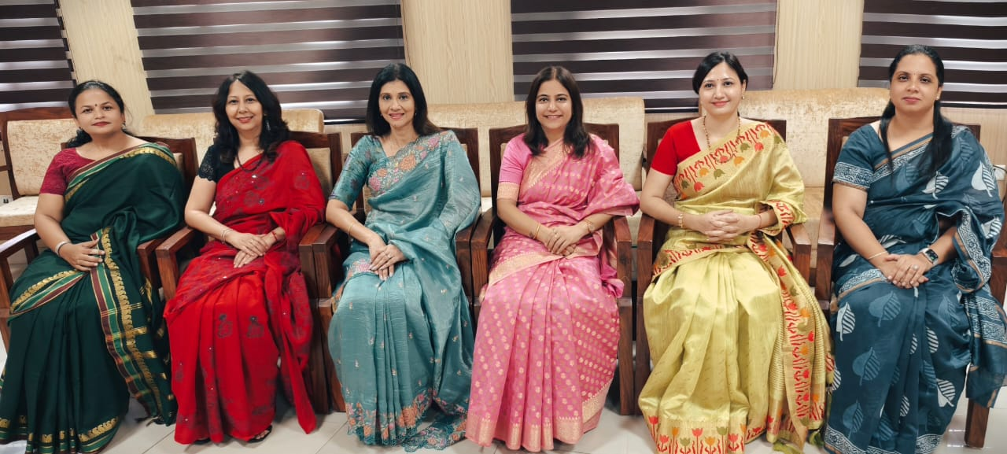
L to R: Dr. Richa, Dr. Sapna Sachdeva Nair, Principal Mrs. Ritika Gupta, Dr. Sapna Nagpal, Dr. Usha Dahiya, Mrs. Ramanpreet

TEACHING FACULTY
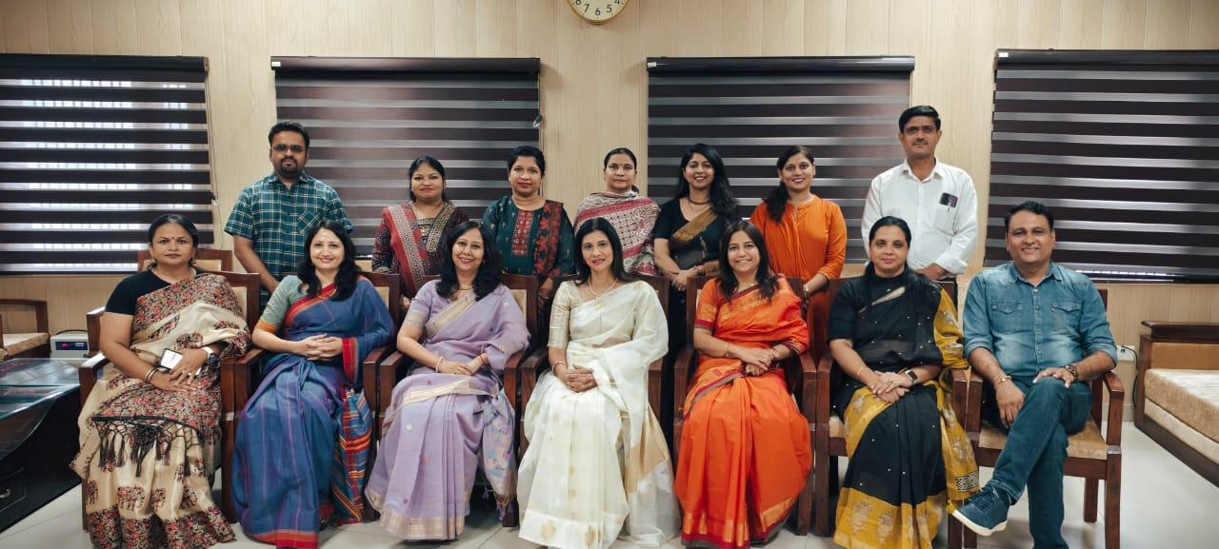
Principal Mrs. Ritika Gupta (Centre) with staff members

LIST OF TEACHING STAFF

Sr. No. | Name | Designation | Subject
1. | Mrs. Ritika Gupta | Principal | Psychology
2. | Dr. Sapna Nagpal | Professor | Computer Science
3. | Dr. Sapna Sachdeva Nair | Associate Professor | Psychology
4. | Mrs. Usha Dahiya | Associate Professor | Computer Science
5. | Mrs. Ramanpreet Kaur | Assistant Professor | Commerce
6 | Dr. Richa | Assistant Professor | Political Science
7. | Mr. Chander Shekhar | Assistant Professor | Hindi
8. | Dr. Shivani Yadav | Assistant Professor | Commerce
9. | Dr. Bhawna Kaushik | Assistant Professor | Computer Science
10. | Dr. Amol Singh | Assistant Professor | English
11. | Dr. Dharmvir Singh Vashisth | Extension Lecturer | Mathematics
12. | Ms. Divya | Extension Lecturer | Physics
13. | Dr. Chanchal | Extension Lecturer | Physics
14. | Dr. Poonam Malik | Extension Lecturer | English

LIST OF NON-TEACHING STAFF
Sr. No. | Name | Designation
1. | Mr. Prem Raj | Dy. Supdt. (Regular)
2. | Mr. Naresh Kumar | Clerk (Regular)
3. | Mr. Shyam Singh | JLA (Regular)
4. | Mr. Son Kumar | Peon (Regular)
5. | Ms. Kanika Rani | Library Attendant (Regular)
6. | Mr. Pradeep Tomar | Clerk (HKRN)
7. | Ms. Raj Rani | Restorer (HKRN)
8. | Mr. Bobby | Lab. Attendant (HKRN)
9. | Mr. Manjit Kumar | Lab. Attendant (HKRN)
10. | Mr. Sikander | Peon-Cum- Chowkidar (HKRN)
11. | Mr. Bhagat Singh | Chowkidar (HKRN)
12. | Mr. Dharambeer | Chowkidar (HKRN)
13. | Mrs. Indra | Sweeper (HKRN)

STUDENT STRENGTH CLASS WISE SESSION 2024-25
Sr. No. | Class | College Roll No. | No. of Students
1. | B.A. 1st Year | 1240501001 to 1240501251 | 238
2. | B.A. 2nd Year | 1230501001 to 1230501247 | 225
3. | B.A. 3rd Year | 1220231002001 to 1220231002245 | 220
4. | B.Com 1st Year | 1244048001 to 1244048079 | 78
5. | B.Com 2nd Year | 1230499001 to 1230499060 | 52
6. | B.Com 3rd Year | 1220231039001 to 1220231039081 | 63
7. | B.Sc. Life Science 1st Year | 1242875001 to 1242875072 | 70
8. | B.Sc. Medical 2nd Year | 1232588002 to 1232588049 | 36
9. | B.Sc. Physical Science 1st Year | 1242874001 to 1242874038 | 34
10. | B.Sc. Non-Medical 2nd Year | 1230822001 to 1230822024 | 20
11. | B.Sc. (I.T) 3rd Year | 1220231015001 to 1220231015022 | 20
12. | BBA 1st Year | 1242586001 to 1242586076 | 73
13. | BBA 2nd Year | 1232586001 to 1232586064 | 55
14. | BCA 1st Year | 1242587001 to 1242587082 | 79
15. | BCA 2nd Year | 1232587001 to 1232587079 | 70
16. | M.A. English 1st Year | 2242742001 to 2242742040 | 40
17. | M.A. English 2nd Year | 2232742001 to 2232742035 | 28
18. | M.A. History 1st Year | 2242743001 to 2242743040 | 40
19. | M.A. History 2nd Year | 2232743001 to 2232743040 | 37
20. | M.Com 1st Year | 2242745001 to 2242745041 | 40
21. | M.Com 2nd Year | 2232745002 to 2232745041 | 37
22. | M.Sc. Computer Science 1st Year | 2242747001 to 2242747027 | 27
23. | M.Sc. Computer Science 2nd Year | 2232747002 to 2232747028 | 20
24. | M.Sc. Physics 1st Year | 2242748001 to 2242748027 | 27
25. | M.Sc. Physics 2nd Year | 2232748001 to 2232748040 | 35
 |  | Total Strength | 1664

BUDGET DETAILS
(Bursar- Dr. Usha Dahiya)

Smt. Sushma Swaraj Govt. College for Girls, Ballabgarh(Budget Recieved from State Govt.)
Sr. No. | Object Code Description | Received/Amount Allocated | Cumulative Expenditure | Balance Amount
1 | 04 Travel Expenses(Administrative Staff) | 15000 | 7690 | 7310
3 | 04 Travel Expenses(Teaching Staff) | 60000 | 43300 | 16700
4 | 67 Medical Reimbursement (Administrative Staff) | 0 | 0 | 0
5 | 70 Leave Travel Concession (Administrative Staff) | 200850 | 36354 | 164496
6 | 70 Leave Travel Concession (Teaching Staff) | 1117452 | 1070550 | 46902
8 | 69 Contractual Service (Ext.) | 1384800 | 1384800 | 0
9 | 69 Contractual Service (HKRN) | 2319920 | 2219939 | 99981
10 | 02 Wages (HKRN & Outsource) | 1588161 | 1588161 | 0
11 | 92 Energy Charges | 700000 | 685977 | 14023
12 | 05 Office Expenses | 60000 | 44914 | 15086
13 | 34 Other Charges (Sports) | 40,000 | 40,000 | 0
14 | 87 Honorarium EWYL | 135000 | 99900 | 35100
15 | 34 Women Cell | 60,000 | 24567 | 35433
16 | 24 M&S (Sc. Exb.) | 15639 | 11767 | 3872
17 | 24 M&S (Aug. & Lab.) | 30030 | 26458 | 3572
18 | 86 Training | 30,000 | 26644 | 3356
19 | 87 Placement Cell | 12448 | 11748 | 500
 | Total | 7769300 | 7322769 | 446331

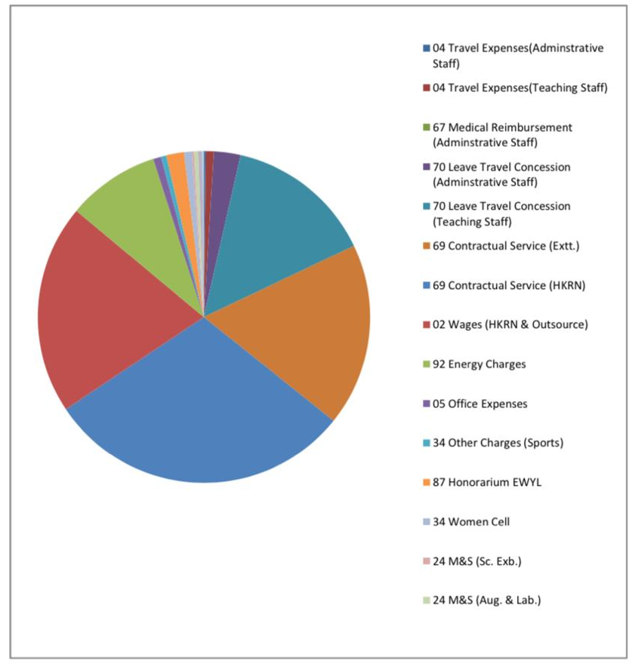

LIBRARY ( Faculty Incharge – Dr. Richa )
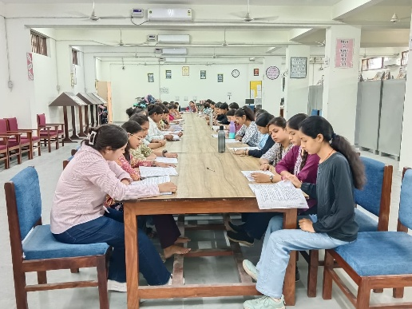
Library Reading Area
The college library is a hub of knowledge and learning, providing students with access to a vast collection of books, journals, and digital resources. Throughout the year, the library has enriched the academic experience of our students and staff by offering a conducive study environment, and resources that cater to diverse interests and needs. The college library has computer, CPU, UPS and photocopy machine

Total Books | 3045
Unique Titles | 1023
Total Text Books | 2497
Reference books | 548
TOTAL BOOKS IN BOOK BANK B.B | 322
New Books added | 1013
NON PRINT MATERIALS | 8

SOFTWARE WORK
3043 BOOKS ENTERED IN SOUL SOFTWARE (ACCESSION REGISTER)
COLLEGE LOGO PASTED ON EVERY BOOK.
DUE DATE PASTED ON EVERY BOOK
BOOK POCKET WITH BOOK CARD PASTED ON EVERY BOOK
BOOKS ISSUE – RETURNS STARTED ON SOUL SOFTWARE 3.0
BAR CODE DONE ON EVERY BOOK

LIST OF NEWS PAPERS: (5)
- दैनिक जागरण (हिंदी )
- नव भारत टाइम्स (हिंदी )
- अमर उजाला (हिंदी )
- The Times of India (English)
- Employment News Paper (English)

LIST OF MAGAZINES: (12) (For One Year) JANUARY 2024 to DECEMBER 2024
- योजना (हिंदी )
- कुरुक्षेतत्रा (हिंदी )
- प्रतियोगिता दर्पण (हिंदी)
- क्रोनिकल (हिंदी )
- आज कल (हिंदी)
- गृह शोभा (हिंदी )
- India Today (English)
- Reader digest (English)
- Yojana (English)
- C.S.R.(English)
- Science Reporter (English)
- Women Era (English)

ACADEMIC RESULTS (Session 2024-25)
(Incharge – Dr. Richa)
B.A. –I Semester
(MAJOR)

S. No. | Subject | Total | Appear | Pass | College Pass %
1 | Hindi | 143 | 135 | 74 | 54.8%
2 | English | 128 | 106 | 82 | 77.3%
3 | Political Science | 143 | 135 | 129 | 95.5%
4 | History | 128 | 121 | 116 | 95.8%
5 | Psychology | 45 | 41 | 36 | 87.8%
6 | Home Science | 55 | 51 | 38 | 74.5%
7 | Economics | 50 | 49 | 43 | 87.7%
8 | Sociology | 55 | 53 | 40 | 75.4%

(MINOR)
S. No. | Subject | Total | Appear | Pass | College Pass %
1 | Hindi | 30 | 28 | 13 | 46.4%
2 | English | 29 | 28 | 25 | 89.2%
3 | Political Science | 24 | 24 | 22 | 91.6%
4 | History | 36 | 33 | 23 | 69.6%
5 | Psychology | 20 | 13 | 11 | 84.6%
6 | Home Science | 29 | 27 | 24 | 88.8%
7 | Economics | 20 | 17 | 09 | 52.9%
8 | Sociology | 49 | 47 | 43 | 91.4%

B.A. –III Semester Result Session 2024-25
S. No. | Subject | Total | Appear | Pass | College Pass %
1 | Hindi | 225 | 220 | 208 | 94.5%
2 | English | 225 | 219 | 210 | 95.8%
3 | Political Science | 129 | 124 | 116 | 93.5%
4 | History | 145 | 141 | 112 | 79.4%
5 | Psychology | 56 | 55 | 39 | 70.9%
6 | Home Science | 62 | 59 | 48 | 81.3%
7 | Economics | 77 | 71 | 30 | 42.2%
8 | Sociology | 60 | 59 | 50 | 84.7%

B.A. –V Semester Result Session 2024-25
S. No. | Subject | Total | Appear | Pass | College Pass %
1 | Hindi | 220 | 217 | 141 | 64.9%
2 | English | 220 | 220 | 101 | 45.9%
3 | Political Science | 133 | 131 | 93 | 70.9%
4 | History | 123 | 122 | 116 | 95%
5 | Psychology | 43 | 42 | 30 | 71.4%
6 | Home Science | 55 | 52 | 48 | 92.3%
7 | Economics | 42 | 42 | 35 | 83.3%
8 | Sociology | 47 | 47 | 42 | 89.3%

B.A. –IV Semester Result Session 2024-25
S. No. | Subject | Total | Appear | Pass | College Pass %
1 | Hindi | 225 | 210 | 202 | 96.19%
2 | English | 225 | 212 | 198 | 93.3%
3 | Political Science | 129 | 123 | 121 | 98.37%
4 | History | 169 | 156 | 103 | 66%
5 | Psychology | 44 | 42 | 36 | 85.7%
6 | Home Science | 81 | 77 | 41 | 53.2%
7 | Economics | 57 | 54 | 34 | 62.9%
8 | Sociology | 55 | 50 | 48 | 96%

B.A. –VI Semester Result Session 2024-25
S. No. | Subject | Total | Appear | Pass | College Pass %
1 | Hindi | 220 | 209 | 198 | 94.7%
2 | English | 220 | 211 | 185 | 87.6%
3 | Political Science | 133 | 126 | 120 | 95.23%
4 | History | 122 | 116 | 110 | 94.8%
5 | Psychology | 43 | 40 | 40 | 100%
6 | Home Science | 55 | 52 | 52 | 100%
7 | Economics | 45 | 43 | 36 | 83.7%
8 | Sociology | 47 | 44 | 40 | 90.9%

B.Com. –III Semester Result Session 2024-25
S. No. | Subject | Total | Appear | Pass | College Pass %
1 | Corporate Accounting – C301 | 52 | 50 | 46 | 92%
2 | Business Statistics – C302 | 52 | 51 | 39 | 76.4%
3 | Business Regulatory Framework – C303 | 52 | 51 | 49 | 96.7%
4 | Corporate Law – C304 | 52 | 51 | 50 | 98%
5 | Data Base Management System – C311 | 52 | 51 | 50 | 98%
6 | Structural Programming & Computer Graphics – C312 | 52 | 51 | 50 | 98%

B.Com. –V Semester Result Session 2024-25
S. No. | Subject | Total | Appear | Pass | College Pass %
1 | Taxation Law – C501 | 63 | 61 | 59 | 98.3%
2 | Cost Accounting – C502 | 63 | 61 | 56 | 91.8%
3 | Accounting for Management – C503 | 63 | 62 | 61 | 98.3%
4 | Financial Market Operations – C504 | 63 | 62 | 61 | 98.3%
5 | Computer Aided Drafting & Advanced Topics in Computer – C511 | 63 | 62 | 60 | 96.7%
6 | Essential of E-Commerce – C512 | 63 | 61 | 60 | 98.3%

B.Com. –IV Semester Result Session 2024-25
S. No. | Subject | Total | Appear | Pass | College Pass %
1 | Corporate Accounting – C401 | 51 | 51 | 38 | 74.5%
2 | Business Statistics – C402 | 51 | 51 | 37 | 72.5%
3 | Business Regulatory Framework – C403 | 51 | 51 | 47 | 92.1%
4 | Corporate Law – C404 | 51 | 51 | 17 | 33.3%
5 | Data Base Management System – C411 | 51 | 51 | 44 | 86.2%
6 | Structural Programming & Computer Graphics – C412 | 51 | 51 | 43 | 84.3%

B.Com. –VI Semester Result Session 2024-25
S. No. | Subject | Total | Appear | Pass | College Pass %
1 | Taxation Law – C601 | 63 | 63 | 56 | 88.8%
2 | Cost Accounting – C602 | 63 | 63 | 54 | 85.7%
3 | Financial Management – C603 | 63 | 63 | 54 | 85.7%
4 | Auditing – C604 | 63 | 62 | 57 | 91.9%
5 | Computer Aided Drafting & Advanced Topics in Computer – C611 | 63 | 63 | 58 | 92.6%
6 | Information Technology in Business – C612 | 64 | 64 | 58 | 92.6%

B.Sc. –I Semester (Life Science) Result Session 2024-25
S. No. | Subject | Total | Appear | Pass | College Pass %
1 | Animal Diversity(24ZOOM401DS01) | 70 | 59 | 42 | 71.1%
2 | Diversity Of Microbes(24BOTM401DS01) | 70 | 59 | 39 | 66.1%
3 | Physics In Everyday Life(24PHY401MI01) | 70 | 58 | 32 | 55.1%
4 | Yoga For Holistic Health(24YOGX01MD01) | 70 | 58 | 43 | 74.1%
5 | Role Of Chemistry In Society(24CHE401SE01) | 22 | 17 | 11 | 64.7%
6 | Hindi Bhasha Sanvardhan(24HNDX01AE01) | 70 | 58 | 45 | 77.5%
7 | Fundamental Chemistry(24CHEM401DS01) | 70 | 59 | 26 | 44%
8 | Digital And Technological Solutions(23CSAX01VA01) | 70 | 58 | 45 | 77.5%
9 | Apiculture
10 | Biofertiliozer & Biopesticides

B.Sc. –I Semester (Physical Science) Result Session 2024-25
S. No. | Subject | Total | Appear | Pass | College Pass %
1 | Fundamentals Of Plant Ecology (24BOT401MI01) | 34 | 33 | 31 | 93.9%
2 | Yoga For Holistic Health (24YOGX01MD01) | 34 | 33 | 32 | 96.9%
3 | Electrical Circuit& Instrumentation Skills (24ELE401SE01) | 34 | 33 | 33 | 100%
4 | Hindi Bhasha Sanvardhan (23HNDX01AE01) | 34 | 33 | 32 | 96.9%
5 | Functions And Algebra (24MATM401DS01) | 34 | 33 | 31 | 93.9%
6 | Fundamental Chemistry (24CHEM401DS01) | 34 | 33 | 23 | 69.6%
7 | Mechanics And Theory of Relativity (24PHY401DS01) | 34 | 33 | 19 | 57.5%
8 | Digital And Technological Solutions (23CSAX01VA01) | 34 | 33 | 27 | 81.8%

B.Sc. (MEDICAL) –III Semester Result Session 2024-25
S. No. | Subject | Total | Appear | Pass | College Pass %
1 | Hindi | 36 | 33 | 30 | 90.9%
2 | Botany | 36 | 33 | 28 | 84.8%
3 | Zoology | 36 | 33 | 29 | 87.8%
4 | Chemistry | 56 | 53 | 51 | 96.2%

B.Sc. (NON-MEDICAL) –III Semester Result Session 2024-25
S. No. | Subject | Total | Appear | Pass | College Pass %
1 | Hindi | 57 | 54 | 52 | 96.2%
2 | Mathematics | 27 | 27 | 18 | 66.6%
3 | Physics | 20 | 20 | 19 | 95%
4 | Chemistry | 56 | 53 | 51 | 96.2%
B.Sc.(IT) –V Semester Result Session 2024-25
S. No. | Subject | Total | Appear | Pass | College Pass %
1 | Fund. Of Information Technology | 20 | 20 | 19 | 95%
2 | Mathematics | 20 | 20 | 17 | 85%
3 | Physics | 23 | 23 | 19 | 82.6%

SCHOLARSHIP ( Incharges - Dr. Shivani and Mrs.Mona)

Scholarship Provided to Students for the Academic Year 2024-25:

- The application forms of 183 students under Consolidated Stipend Scheme and Free Books Scheme for SC Students have been verified.
- The application forms of 82 students under Post Matric Scholarship for BC Students have been verified.

EARN WHILE YOU LEARN SCHEME ( incharge – Dr. Amol Singh)
The Earn while you Learn scheme of college allows students to work part-time on campus gaining valuable work experience and earning a stipend while pursuing their studies.
- 19 students of various disciplines were selected to work under different cells and labs to hone their craft and make them self-reliant.
- Students were paid a specific sum per day and could work for a specific maximum number of days.
- Total 100000 Rs. budget was allotted for the scheme out of which 99900 Rs. was utilized.

IMPORTANT EVENTS
- Havan and Orientation Programme for First year students on 3rd August 2024
- Independence day celebrated on 15 August 2024
- Teachers Day Celebrated on 5th September 2024
- Celebrated Hindi divas on 14th September.
- Celebrated World Mental Health day on 10th October
- Talent search organized on 18th and 19th October.
- Diwali mela on 25th October
- Unveiling of 3rd Edition of college magazine, “Kritivi” on 26th October
- Participated in Zonal youth Festival from 10th to 12th November
- Participated in Inter Zonal Youth Festival from 18th to 20th November
- MoU signed with Lotus Petal Foundation to conduct skill based courses for students.
- Sweater Distribution and Anaemia checkup Camp organized on 13.1.25
- Lohri celebration on 13th January 25
- Celebrated National Voters Day by participating in various activities like essay writing, rangoli making, Oath taking, etc. on 25th January 2025.
- Republic Day celebrated on 26th January 2025
- Organized college level Science exhibition on 4th February 2025
- Participated in Inter district Science exhibition at GCW on 5th February 2025
- One National Workshop on Empowering Educators successfully organized on 8th February 2025.
- Monitored National De worming day on 11th February 2025.
- Successfully organized Sports Day in college on 14th and 15th February 2025.
- Participated in State Level Science exhibition in the subject of Psychology22nd February 2025
- Celebrated Women day and Holi on 8th March 2025
- Successfully participated and completed Cyclothon 2.0
- Centre for NEET exam held on 4th May 2025
- Farewell Party organized on 7th may 2025
- International Yoga Day Celebrated on 21st June 2025

ABOUT CELLS and CLUBS

Our college is vibrant with various cells and clubs that cater to diverse interests and passions. These cells and clubs not only enrich college campus life but also play a crucial role in shaping well-rounded individuals prepared to make a positive impact in society. Through active participation, students can explore their talents, build networks, and create lasting memories.

IQAC (Incharge – Dr. Sapna Sachdeva Nair)
The Internal Quality Assurance Cell (IQAC) of the college works towards maintaining and enhancing quality of Education, research and other activities within the institution. Following are some of the activities carried out under the agies of IQAC
- An industrial visit to NSIC was conducted on 09.09.24.
- A 15-day certificate course in Python programming was conducted in collaboration with NSIC Faridabad Branch from 14.10.24 to 28.11.24.
- An MoU was signed with Lotus petal foundation on 12.12.24 to conduct skill-based courses for students, aiming to provide them placement opportunities.
- Sh. Sushil Kumar from sector 25 fire station led a mock drill on fire extinguishing on 20.09.24.
- Dr Bhawna Arora gave an extension lecture on "Mindful eating small steps, big changes" on 23.11.24.
- Self defence training was provided to girl students by Ms. Sunita, Mahila Thana, Ballabgarh under the agies of IQAC and Women cell
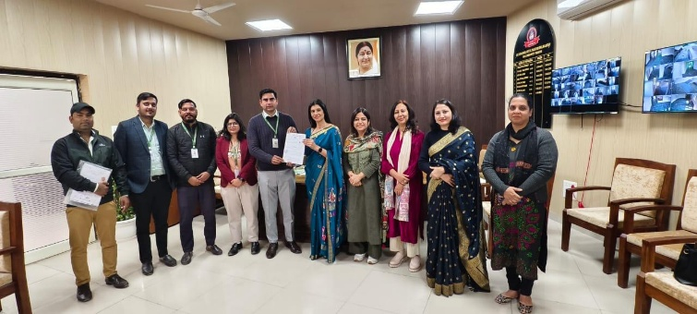
MoU was signed with Lotus petal foundation on 12.12.24
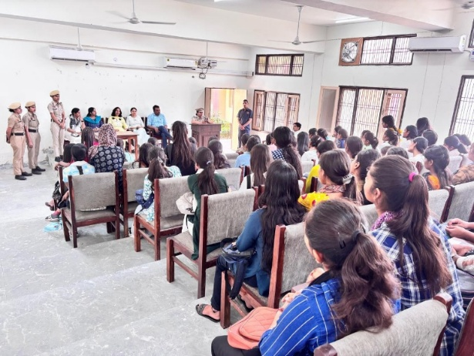
Self defence training address by SHO, Ms. Sunita, Mahila Thana Ballabgarh

RESEARCH AND DEVELOPMENT CELL ( Incharge -Dr. Sapna Sachdeva Nair)
- A one day National Workshop On Empowering Educators was successfully organized On 8th Feb 2025 . Capt. (Dr.) Sunaina Singh, Faculty, Kamla Nehru College, Delhi University conducted a session on - Emotional Intelligence In Academa : Strengthening Teacher Student Dynamics. The second expert, Dr Namita Gupta, Ex-Head/Scientist G, Deptt. Of Science and Technology, Ministry Of Science and Technology, GOI conducted post lunch session on ”Farmulating Research Proposal For Extra Mural Research Functioning.” The Workshop Was Attended By 50 College Teachers/ Professor /Educators From various Institutions. There was Active Participation By District Higher Education Office and Principals of other Colleges.

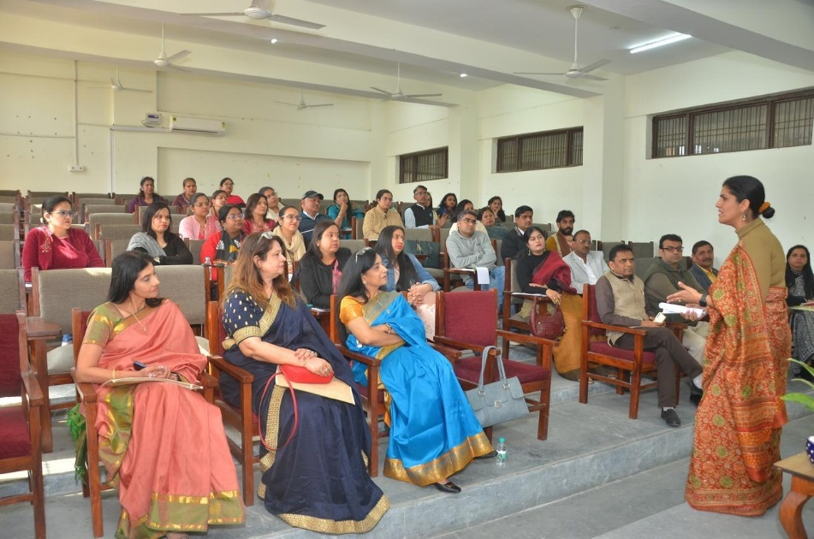
Capt. (Dr.) Sunaina Singh, Faculty, Kamla Nehru College, Delhi University
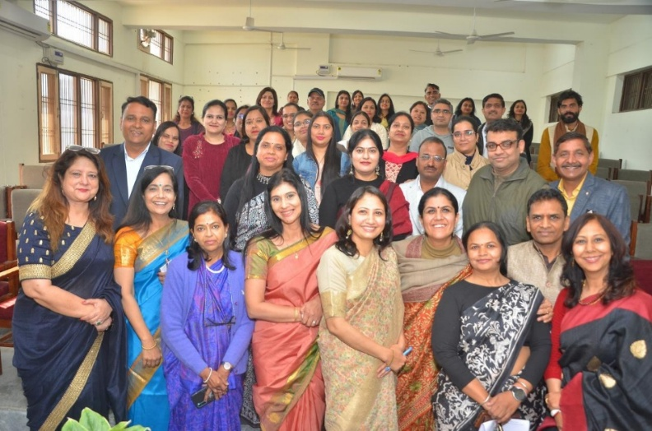
Principals of colleges along with experts and participants of workshop
- Project proposal in collaboration with Public Health Foundation of India (PHFI) on the topic,” what are the expressed needs and strategies to empower women acid attack survivors in their social life in Delhi NCR?” was submitted to SVRI sexual violence research initiative.

NSS (Incharge – Ms Divya)
- Har Ghar Tiranga Celebration under Azadi Ka Amrit Mahotsav
- One day NSS camp on 16-Aug-2024 on “Ek Ped Maa Ke Naam”
- Constitution Oath Ceremony on 17th January 2025
- Suryanamskar Abhiyan from 20th January 2025 to 25th January 2025
- Cleanliness drive and Tree Plantation Drive during One Day NSS Camp on 6th February 2025
- Albendazole Medicine Distribution Program on 11th February 2025
- 7 Days NSS Special camp from 19-02-2025 to 25-02-2025
- Anjali Choudhary of BCA-1st Year participated in online poetry contest on “Women Empowerment Celebrating She Power” i.e. organized by the NSS Cell, M.D.U. Rohtak
- Tanisha participated in District level slogan competition and Chandani participated in District level Poster Making competition i.e. organized by NSS unit of GCW, Faridabad on 7th April 2025
- Cyclothon 2.0. On 11th April 2025 approximately 35 NSS Volunteers have contributed to Anti Drug campaign of Haryana Government by participating in the Cyclothon 2.0. on “drug Free Haryana”
- Dr. B.R. Ambedkar birth anniversary Celebration on 13th April 2025.
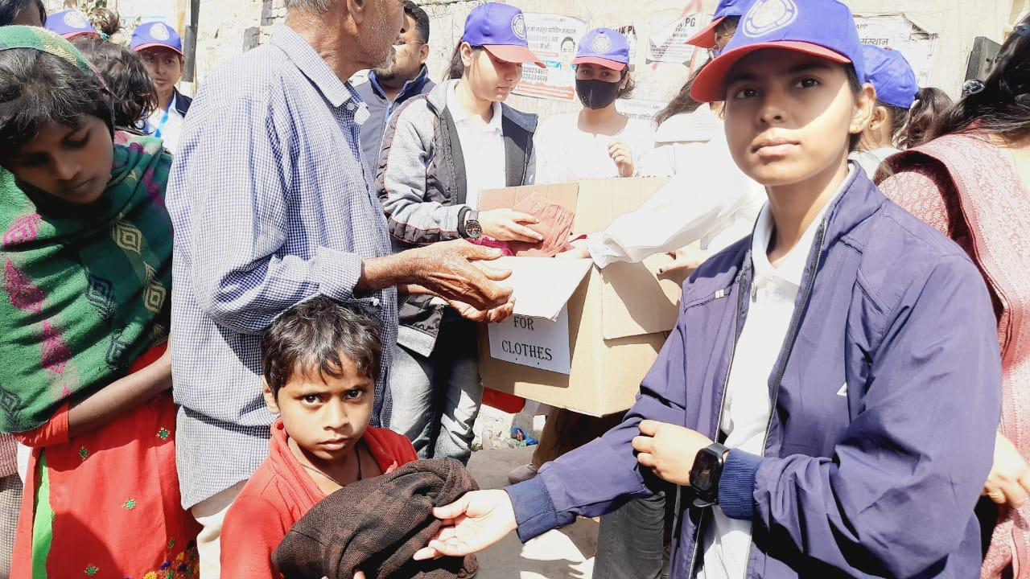
Food and Clothes Donation drive
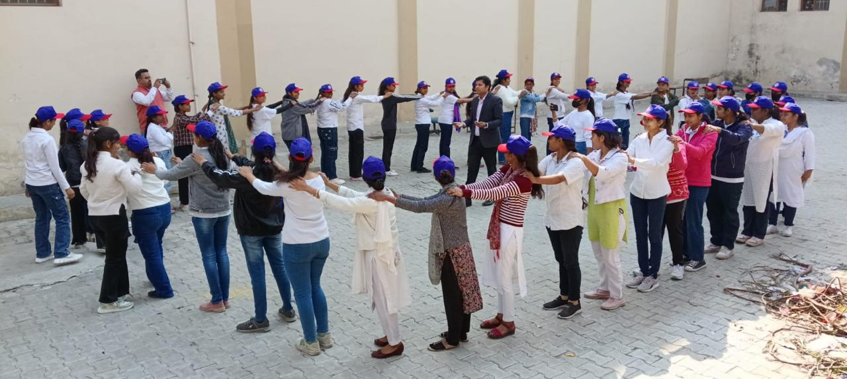
Stress Management Activity

PLACEMENT CELL (Mrs. RamanPreet Kaur)
- A one day workshop on mutual funds was organized on 6th aug.2024 sh. Surya kant sharma ex-dgm sebi addressed the students about savings and investment under investor awareness Programme.
- An extension lecture on “artificial intelligence “was organized by Dezinic Academy on 23rd oct.2024 powered by e-max institute by Mr. Lokesh Bidruri.
- A lecture on “personality development” was held on 14th Aug. 2024 Mr. Shubham Verma (soft skill trainer) took the session and it was attended by 100 students.
- An MOU has been degined with “lotus foundation” an NGO for conduct of 240 hr training of students an various subjects like digital marketing, bfsi, computer hardware & networking.
- Attended training at district level held on 18th march 2025 under tpo workshop at GCW, Faridabad.
- On 9th march 2025 an extention lecture on “various career options after graduation ” was organized dr. Sandhya & dr. Sanjay Gandhi from Ramanujan college addressed 70 students.
- An extension lecture was organized on 8th April 2025 Ms. Rajni “Aravali Institutes ” addressed 70 students on “Personality Development”.
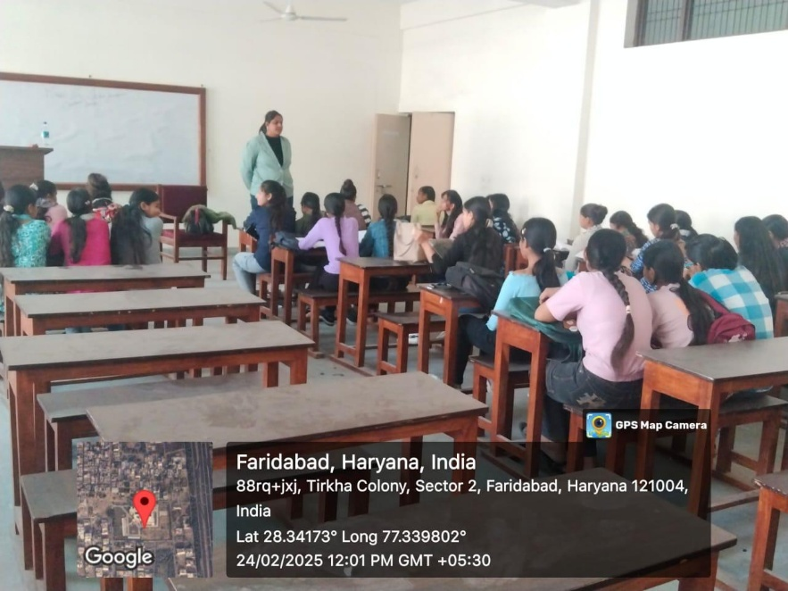
Workshop on Interview skills by Magic Bus India foundation

CULTURAL CELL (Incharge- Dr. Sapna Sachdeva Nair)
The Cultural Cell of the college is a vibrant and dynamic entity that plays a pivotal role in fostering creativity, diversity and inclusivity on the campus. The cell offers opportunities to students to showcase their talents, develop necessary soft skills like teamwork, communication and confidence . Following activities were carried out under the cell:
- Celebrated Teachers Day on 5th September 2024.
- Successfully organized Talent Search on 18-19th October 2024 providing platform to students to showcase their talent in various art forms such as fine arts, speech, poetry, dance and music.
- Students participated in Zonal Youth Festival held at Aggarwal College, Ballabgarh on 10-12 November 2024 in Literary , Fine Arts and Theatre Events.
- Achievements : 1st Position In Painting , Photography , Mehndi
    - 3rd Position In Mime , Cartooning and Poster making.
- Students actively participated in Inter Zonal Youth Festival Held at M.D, University, Rohtak on 18-20th Nov 2024 in Mime and Fine arts category and secured 2nd position in Mehndi, Painting and Poster making and 3rd position in Cartooning.
- The cell also played an active role in organizing and celebrating various festivals and the farewell of the final year students fostering a sense of community and camaraderie among students.

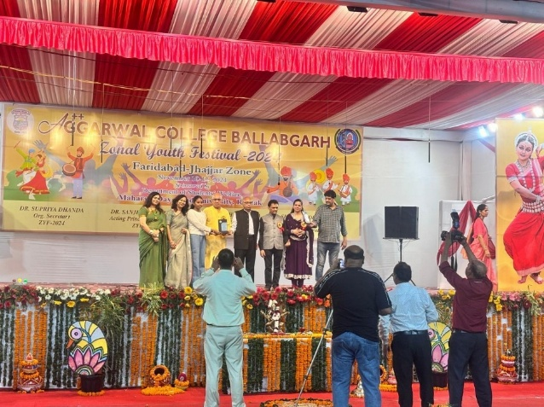
Student Madhu receiving trophy for poster making at Zonal Youth Festival
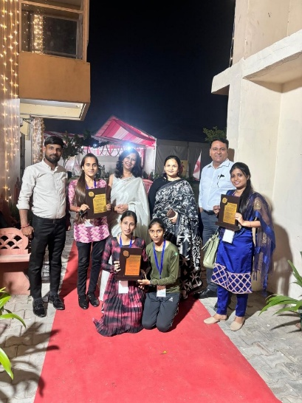
Prize winners of Fine Arts Events at Zonal Youth Festival along with Incharges
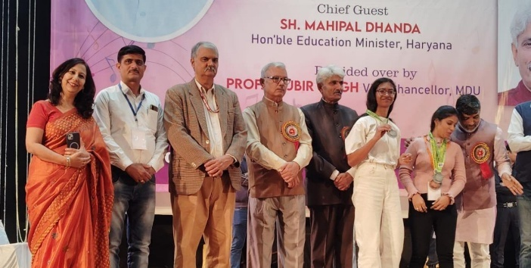
Prize winners at Inter Zonal Youth Festival, M. D University, Rohtak

LEGAL LITERACY CELL (Incharge- Mrs. Ramanpreet Kaur )
An Oth Was Taken Reading The Preamble On 17th Jan 2025 And Contributed To “Hamara Samvidhan Hamara Swabhiman” An Initiative By Ministry Of Culture.
Voat Awareness Rally Was Organised In Main Market Ballabhgarh On 21/02/2025 In Collaboration With NSS Unit Of College.

WOMEN CELL ( Incharge- Dr. Shivani)
- A Craft Workshop Was Organized On 4th Nov. 2024 By Hast Shilp Kala Jaipur In Girls Common Room Around 50 Students Participated.
- De-Worming Day -18th Sep. 2024. Mop Up Day - 24th Sep. 2024. De-Worming Tablet Were Distributed To Students = 500 Tablets.
- A Lecture On Nutrition Was Held On 23rd Nov. 2024 By Dr. Bhawna Arora , Ayurvedic Physician , Clinical Nutritionist & Weight Loss Manager For Faculty & Girls Students.
- Motivated Students To Participate In District Level Painting Competition Organized By “Mission Jagriti” An Ngo On 17th Nov. 2024 Held At Rally Ground Sector-12. Manisha Of B.A. Won 3rd Prize.
- 2 Days Yoga For Molistic Healt (0.2*02=04) Lecture Were Organized On 2nd & 3rd Dec 2024 By Mr. Vijender Kumar. Around 150 Students Participated In The Same.
- A Master Class On Personal Grooming Was Taken By Mrs. Richa & On 19th Nov. 2024. Attended By 100 Students.
- An Anaemia and Diseases Check By Camp Was Organized On 13th Jan 2025 In Collaboration With B.K Hospital , Bharat Vikas Parishad.
- P & G Awareness On Menstrual Health On 13th Jan. 2025.
- Extension Lecture On Cervix And Uterus Cancer By Women Cell On 25th Feb. 2025 By This Organization And Sanitary Pads.
- YRC & Women Cell Celebrated World Oral Health Day Talk On Oral Hygiene By Dr. Jimmy , AIIMS BLB On 20th March 2025.
- Ms. Sunita, SHO Ballabgarh delivered Lecture On “Women Safety” On 21st March 2025.
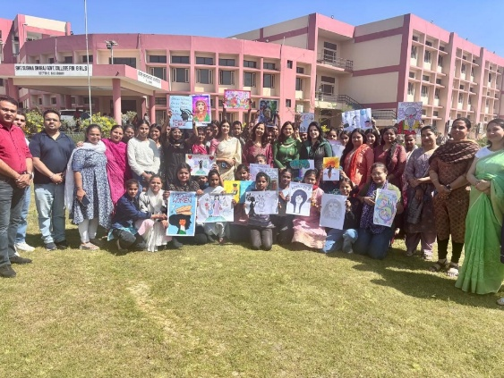
Celebrating International Women’s Day on 8th March 2025
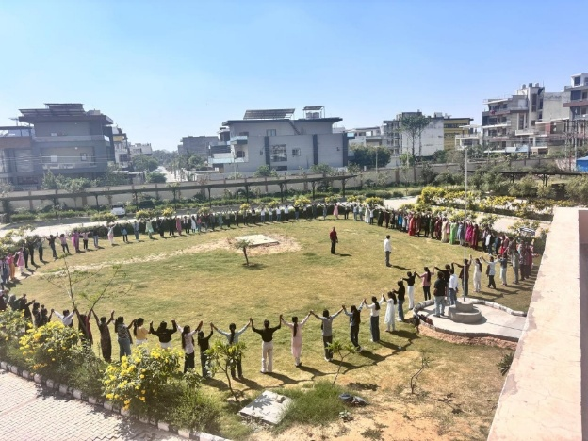
Demonstrating Solidarity through Human chain on Women’s Day

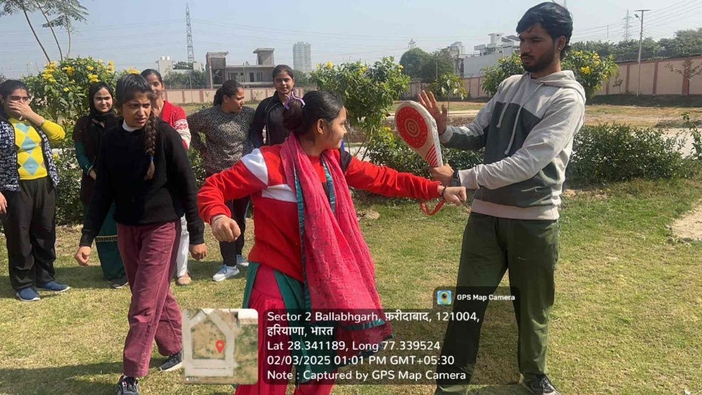
Self Defence Training for Girls

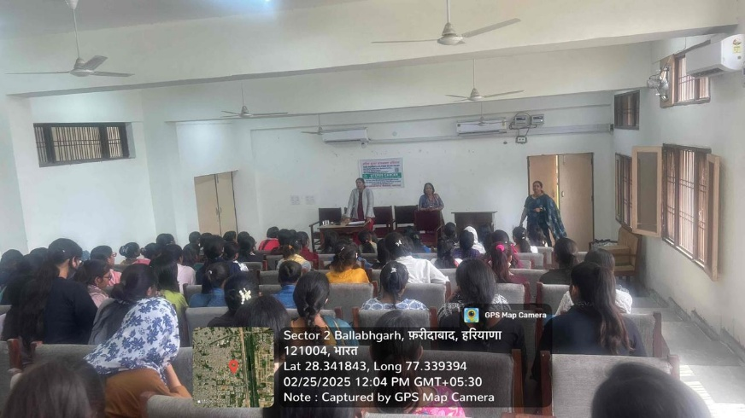
A uterus cancer awareness lecture for girl students on 25 Feb 2025

YOUTH RED CROSS (incharge- Dr. Bhawna Kaushik)
- Lecture On Nutrition By Dr. Parul Parashar (Batra Heart & Multispeciality) On 31st Aug. 2024.
- National Demorning Day Celebrated On 18th Sep 2024 On That Day 129 Girls Were Given Albendazole Tablet Mop Up Day On 24th Sep 2024 Distributed Albendazole Tablet On that Day.
- Motivated Students For Participation In District Level Drawing Competition On Female Forticide In Collaboration With Mission Jagriti On 17th Nov. 2024 Held At Rally Ground . Manisha Won 3rd Prize At District Level.
- Lecture On Nutrition On 23rd Nov.2024 Dr. Bhavna Arora , Ayurvedic physician Gave Lecture On Nutrition And Weight Management.
- Two Days “Yoga For Molistic Health” Lecture On 2nd & 3rd Dec,2024 By Mr. Vijender Kumar
- Anemia Check Up Camp Held On 13th Jan 2025
- 180 Sweaters Were Distributed To Needy Girls Students On 13th Jan 2025.
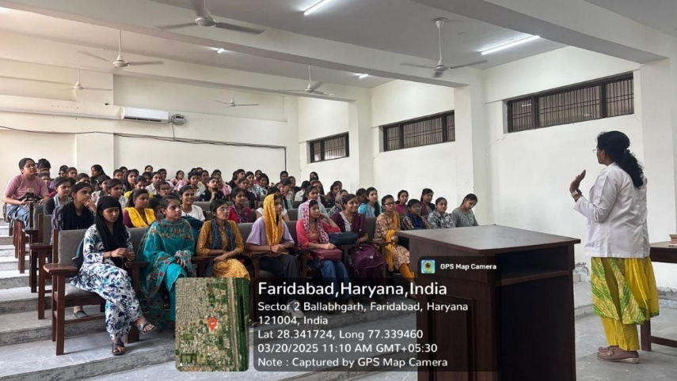
Youth Red cross and Women Cell celebrated world oral health Day. On this occasion a talk was organized on topic oral hygiene
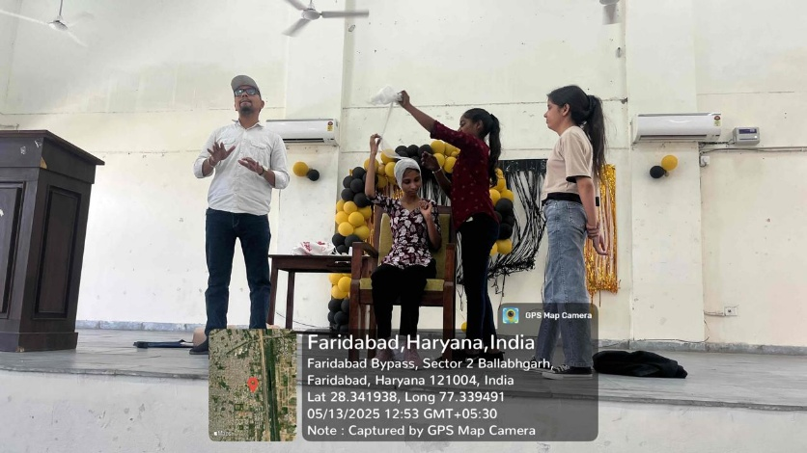
Disaster response training given by Red Cross Society experts

ECO CLUB (Incharge- Dr. Sapna Nagpal)

The Eco club in the college is established to spread awareness about environmental pollution and to reduce anti-environment activities in the college campus. It is committed to prepare and organize students’ participation for preservation and conservation of environment. The college recycles the green waste by digging pits and burying the dry leaves and other biodegradables. Various activities and events are organised under the club to maintain the greenery in the college and create sense of responsiveness for the environment.
- The Eco Club organised Tree Plantation in the college on 13/07/2024 in collaboration with Horticulture Department, Faridabad to create green belt in the college. Around 500 plants were planted to make the college building green and beautiful.
- Students painted wall in the college for creating awareness on environment on Environment Day on 05.06.2025 under the aegis of Eco Club.
- Tree Plantation under “Ek Ped Maa Ke Naam” drive on 06.06.2025
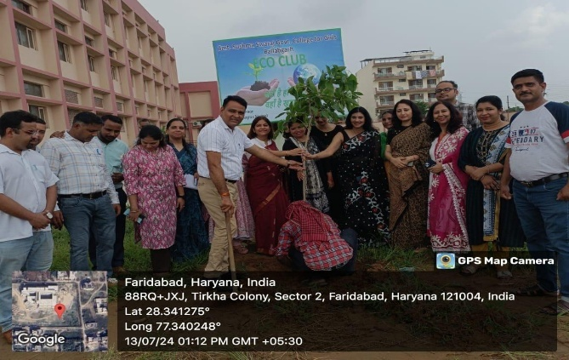
Tree Plantation
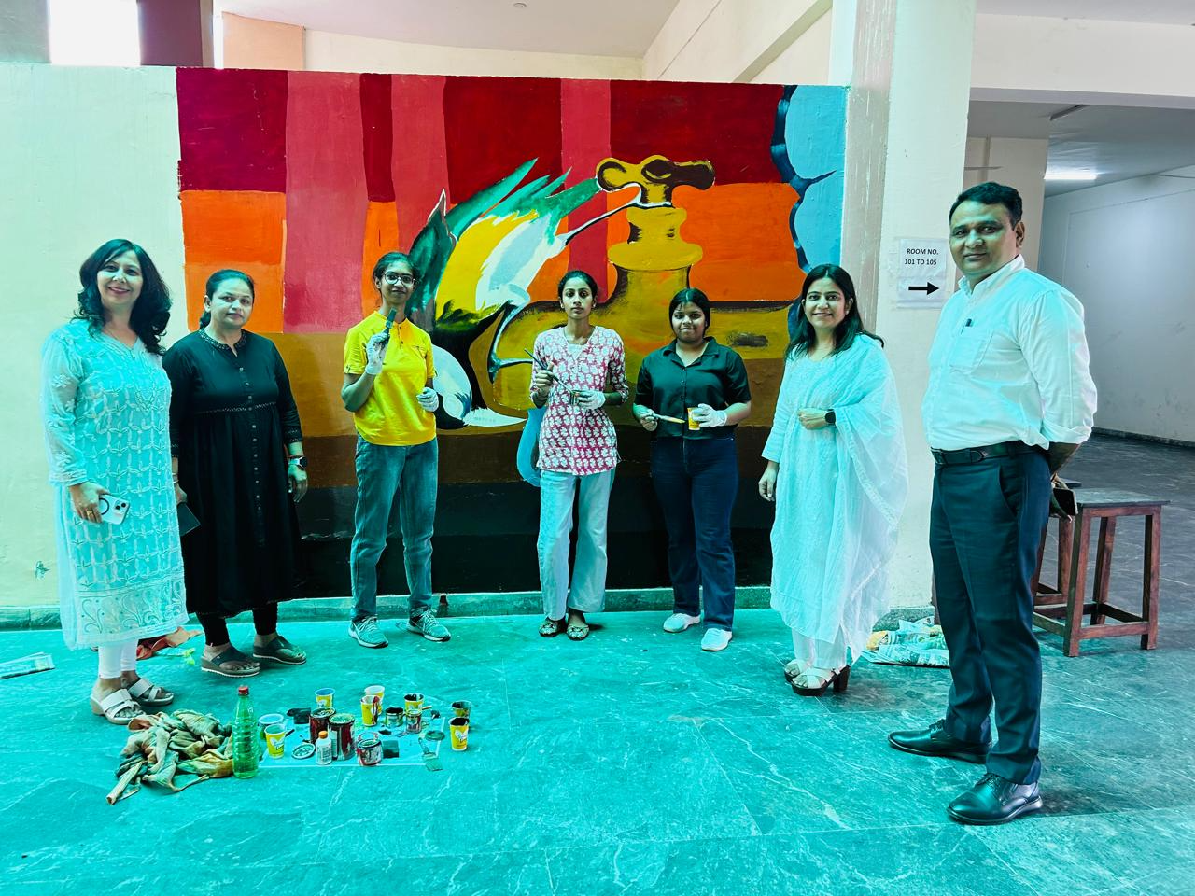
Wall Painting by Students on Environment Day June 5, 2025

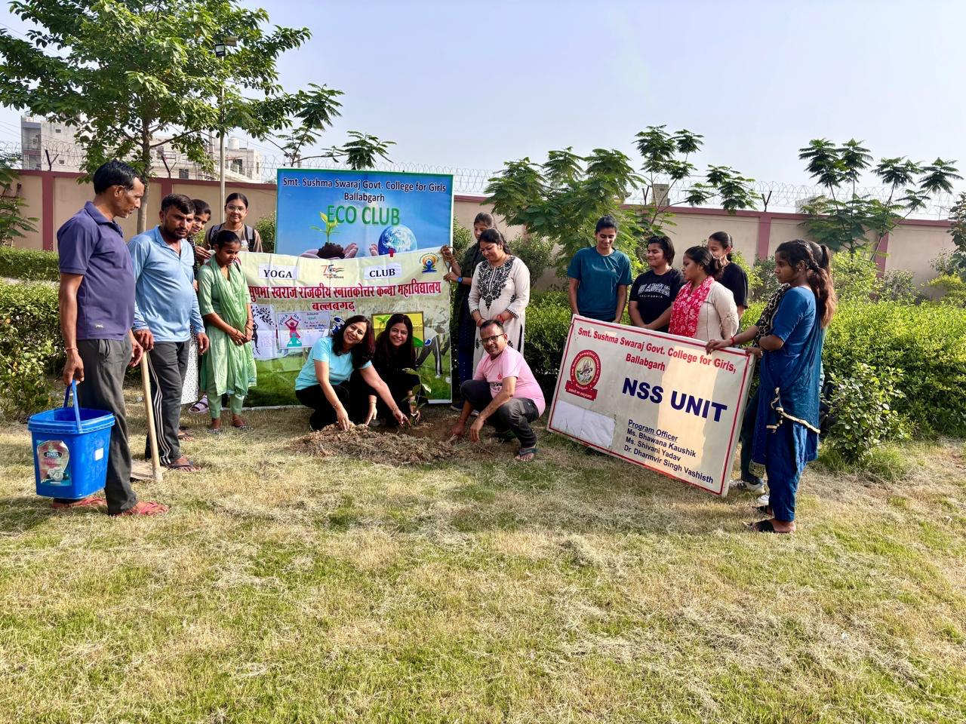
Tree Plantation on June 6, 2025 under “Ek Ped Maa Ke Naam”
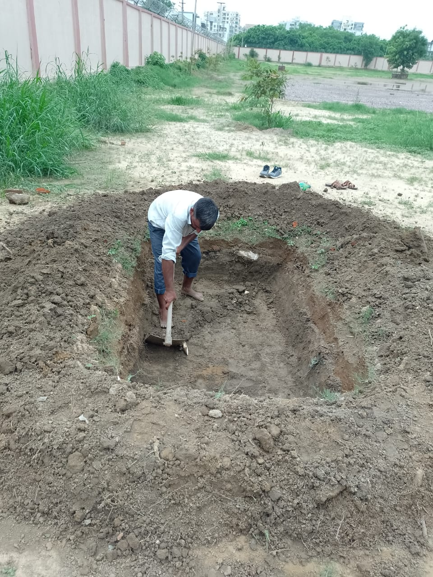
Pit for burying green waste in soil

SPORTS CLUB ( Incharge Sh. ChanderShekhar)
The Sports Club of our college fosters teamwork, discipline, and sportsmanship among students of college. Throughout the year the club has provided students with apple opportunities to develop their skills and showcase their talents varied sports events. Sports day was successfully organized in college on 14th and 15th February 2025 in which students actively participated in Races, shot put, high jump long jump, Javelin throw, etc.
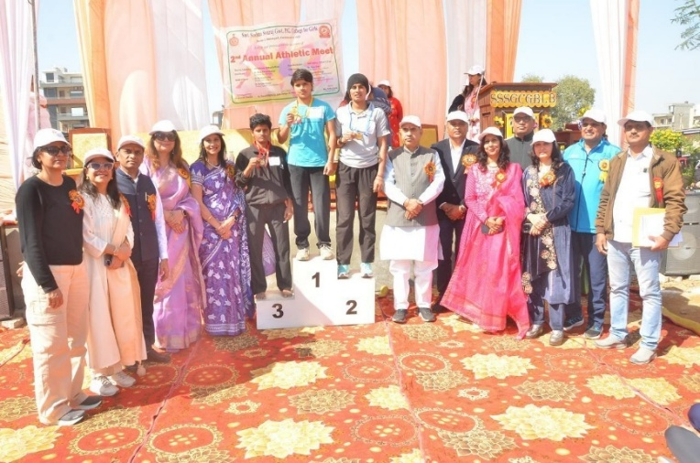
Winners with Principal Mrs Ritika Gupta, Honorable Mool Chand ji, MLA Ballabgarh, Sports Incharge Sh. Chander Shekhar along with other Dignitaries
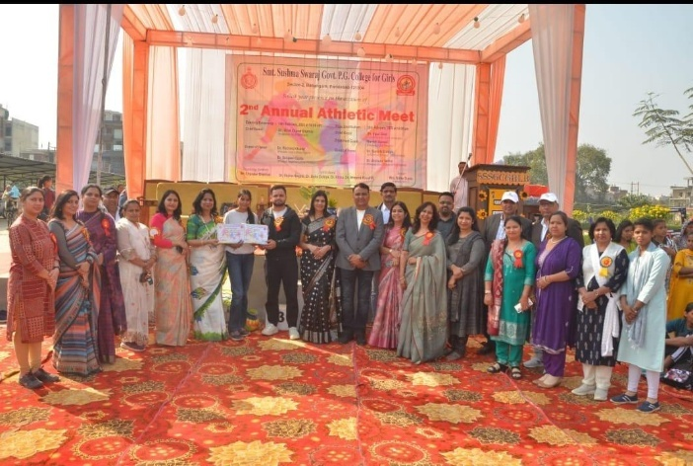
Winner receiving Certificate from Mrs. Sunidhi, DHEO, Faridabad

ANTI TOBACCO & ANTI – DRUG CELL REPORT (Incharge – Dr. Dharamvir Vashishtha)

Sr. No. | Date | Name Of Activity | Speaker/Chief Guest | No. Of Student
1 | 10th July 2024 | One Day Seminar & Awareness Programme On Drug Abuse Prevention To Celebrate “World Drug Day” | Dr. K.L Kaushik | 125
2 | 7th Aug 2024 | 2 Students Participated In Inter College Ppt Making Competition “Say No To Drug”& Got 2nd Position. | GCW Online Inter College Ppt Making Competition. | 2
3 | 12th Aug.2024 | “Viksit Bharat Ka Mantra, Bharat Ho Nashe Se Swatantra” | Dr. Ritika Gupta | 200
4 | 18th Sep. 2024 | One Day Seminar On Awareness Of Drug Abuse And Its Harms | Dr. Darshan Sharma, Dr. Vinita Sharma, Dr. Shilpi Bansal & Dr. Deepak Sharma | 114
5 | 19th Oct.2024 | Poster And Slogan Exhibition For Sanitizing The Students About The Drugs | Dr. Ritika Gupta | 115
6 | 26th Oct.2024 | Police Ki Pathshala  (Awareness Of Cyber Security , Cyber Crime & Anti – Drug) | Asi Surrender Dahia & Si Virender Balhara | 105
7 | 8th Nov. 2024 | NMBA Session By The Art Of Living | Mr. Jonny Goyal, Taniya Arora, Hema Sharma | 125
8 | 27th Nov. 2024 | Nukkad Natak On Awareness Drug Abuse | Dr. Dharmvir Singh | 17
9 | 7th Dec. 2024 | Poster & Slogan Rally For Community Awareness About Drugs | Dr. Dharmvir Singh | 138
10 | 10th Jan. 2025 | Pledge On Stay Away From Drugs | Dr. Ritika Gupta | 115
11 | 7th Feb.2025 | Mehandhi Competition On Nasha Mukt Samaj | Dr. Dharmvir Singh | 118
12 | 24th March 2025 | Lecture & Rally About Awareness On Drug Addiction | Dr. Dharmvir Singh | 50
13 | 7th April 2025 | Drawing And Painting Competition Under “Drug Free Haryana” Scheme Cyclothon 2.0 | Dr. Ritika Gupta | 110
14 | 8th April 2025 | Lecture On Anti Drug (NCORD) | Dr. Dharmvir Singh | 300
15 | 11th April 2025 | Ek Cycle Yatra Nasha Mukt Ke Naam Cyclothon 2.0 | CM Nayab Singh Saini | 100

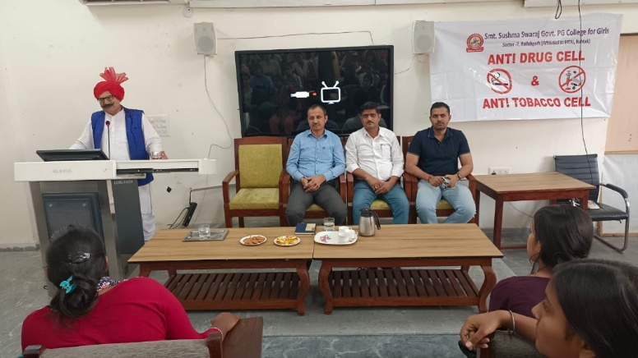
Anti Drug awareness lecture in police ki pathshala on 26.10.24
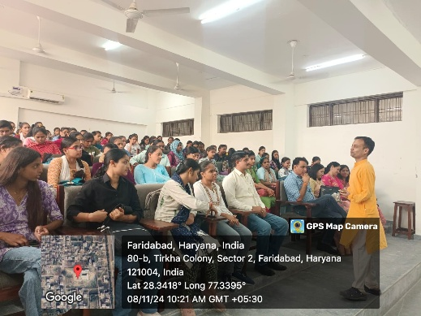
Lecture by Art of Living team on Anti Drugs 08-11-2024

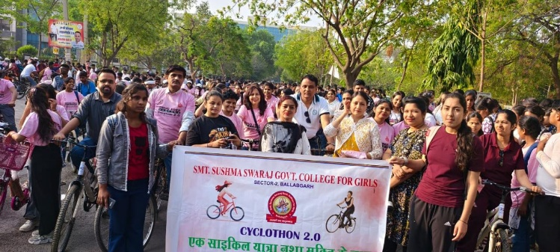
Cyclothon 2.0

YOGA CELL ( Incharge Mrs. Chanchal)

- Two-Day Yoga Program for Holistic Health
Date: 2nd & 3rd December 2024
Description: A two-day yoga session focusing on holistic health was conducted to instill the importance of yoga in daily life. Various yoga asanas, breathing techniques, and meditation practices were demonstrated and practiced. Participation: Around 150 students participated actively in this event.
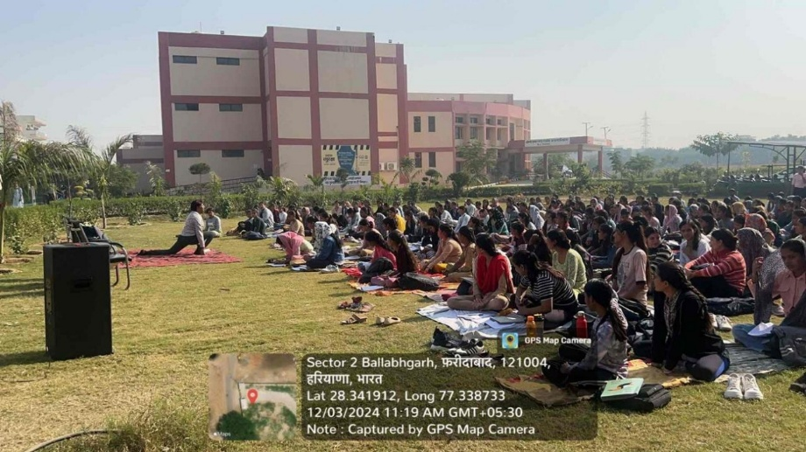
Yoga activity for 2 days i.e. 2nd & 3rd Dec,2024 under women cell

- Suryanamaskar Project
Date: 20th to 25th January 2025
Organized by: Haryana Yog Aayog
Description: As part of the Suryanamaskar Project by Haryana Yog Aayog, students engaged in daily suryanamaskar practice for five consecutive days. Participation: Around 50 students took part in the initiative with enthusiasm.
- Yoga Abhyas Session
Date: 22nd February 2025
Organized by: Yoga Cell in collaboration with NSS
Guided by: Ms. Aruna Chaudhary, Haryana Yog Aayush
Description: A practical yoga session (Yoga Abhyas) was held under the guidance of Ms. Aruna Chaudhary. Students were introduced to various yoga postures and breathing exercises to enhance their physical and mental strength.
- Yoga Lecture Session
Date: 23rd February 2025
Organized by: Yoga Club in collaboration with NSS
Speaker: Ms. Aruna Chaudhary, Haryana Yog Aayush
Description: A comprehensive lecture on the benefits of yoga, stress management, and yogic lifestyle was delivered. The session was highly informative and motivated students to adopt yoga in their routine.
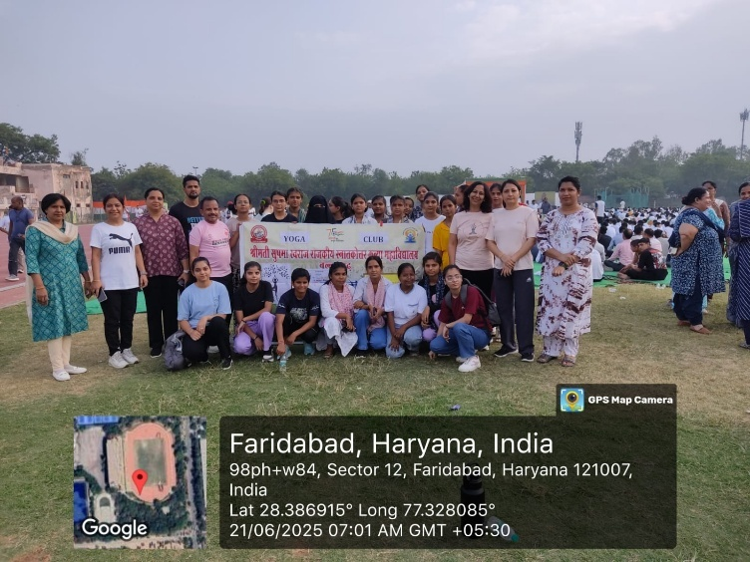

Celebrating International Yoga day on 21st June 2025

INDIAN KNOWLEDGE SYSTEM (IKS) ( Incharge- Sh. ChanderShekhar)
A sacred 'Havan' ceremony was conducted in the college premises as part of Indian knowledge system initiative to mark the auspicious beginning of new academic session on 24th August 2024.

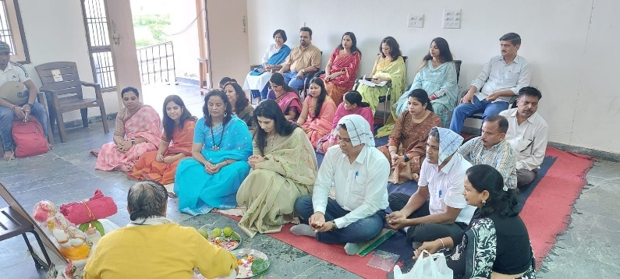
Havan being performed in campus

ROAD SAFETY CLUB ( Incharge- Dr. Ramanpreet Kaur)
- College level road safety quiz was organized on 12th nov,2024.350 (approx) under level-4 participated .
- 2nd level inter level road safety quiz was held on 5th dec.2024 held at govt. Model Sanskriti Sr. Sec. School. 3 students participated from our college as a team.
- Poster making and essay writing competition were held on the theme “Sadak Suraksha Jeevan Raksha” on 23rd Jan. 2025.
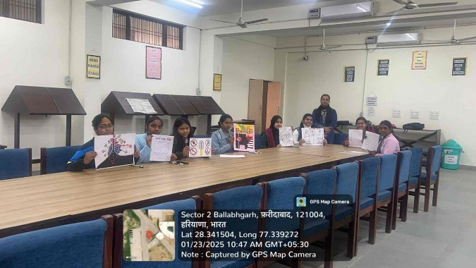
Poster making and essay writing competitions under road safety club on 23rd January 2025

VOTERS CLUB ( Incharge- Dr. Amol Singh)
- EDMS Data collected of employees of the college for MCF election March 2025 on 10 Feb 2025.
- 15th National Voters Day celebrated with great fervour and enthusiasm along with students taking a pledge. Cash prizes given to students under various activities like speech competition, essay writing competition, and rangoli competition.
- Celebration of Constitution Day on 26/11/2024. Declamation and poster making competition took place.
- Lok Sabha Election 2024: Information regarding employees dispersed to the department and the election commission under Voters Club.
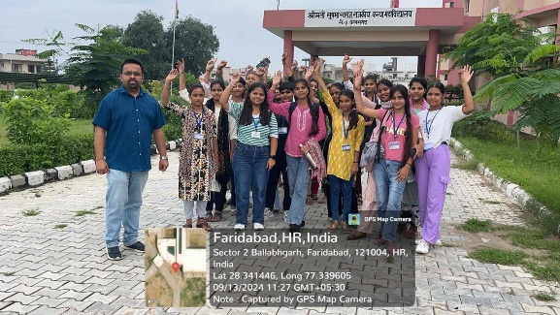\
Voter awareness rally organised in the college on 13/09/2024

DEPARTMENTAL REPORT
The various departments of Colege marked a significant achievements and remained committed to academic excellence and student growth. Department wise activities are listed below:
DEPARTMENT OF COMPUTER SCIENCE
The department of Computer Science has M.Sc (Computer Science), BCA and B.Sc. (IT as a subject) courses. The faculty of the department of Computer Science also teaches B.Com (Vocational–Computer Applications), BBA and VAC courses. There is one Computer Lab and one Computer-cum-Language Lab in the college. The computer-cum-language lab has Digital Teaching Device with interactive board and LCD projector and networking of computers is done. There is total 30 computers in both the labs. The Computer Labs are well maintained to run practical classes. The students conduct their computer practical under the observation of faculty of the department of Computer Science.
In the session 2024-2025, the following activities/events were accomplished by the Deptt. of Computer Science:
- The Department of Computer Science organized a Short-Term Certificate course on “Python Programming” from 14.11.2024 to 28.11.2024 in collaboration NSIC, Faridabad.
- Pragya Maurya, BCA II year and Pooja, B.Sc (IT as a subject) III year secured 2nd position in ”Anti-Drug PPT Competition” organized by district administration in Govt College for Women, Faridabad on 07.08.2024.
- Shruti, BCA II year secured 3rd position in District Level Science Essay Writing Competition held at GC, Faridabad on 18.10.2024
- Shruti and Mehak, BCA II Year secured 2nd Position in Inter District Science Exhibition on 05.02.2025 held at GCW, Faridabad for the Model “Jack: a Virtual Companion”. Mehak was also awarded as ‘Best Explainer ‘.
- One Day Workshop was organized for students on “Introduction to Skill Courses” by Mr. Ravi Goswami, Lotus Petal Foundation, Sohna.
- Mehak, BCA II year got 2nd prize in “Digital Poster” in Technobuzz 2025 held by the Department of Computer Science, K L Mehta College, Faridabad.
Expert Lectures organized
- Expert Lecture was conducted by Mr. Deepak Sharma, Technology Consultant, Infosys ltd. on 21.08.2024 on the topics “Database Applications” and “DBMS Languages”.
- Expert Lecture was conducted for B.C.A. I year by Ms. Vandana Kumari, Associate Professor in Mathematics, Govt. College, Tigaon on 14.11.2024 on the topics “Set Theory” and “Relation and Function”.
- Expert Lecture was conducted by Dr. Renu Chwala, Sarvodya Hospitsl, Faridabad in collaboration with Umar Ujala Foundation on 21.02.2025.
- Expert Lecture was conducted for BCA II Year and B.Com students by Mr. Narender Mehndiratta on 20.02.2025 on the topic “ERP”.
- Expert Lecture was conducted for B.Com 2nd Year by Dr. Ritu Sachdeva, Assistant Professor, MRIIS, Faridabad on 24.04.2025 on the topics “Server Side Scripting with Node.js” and “PHP Programming”.
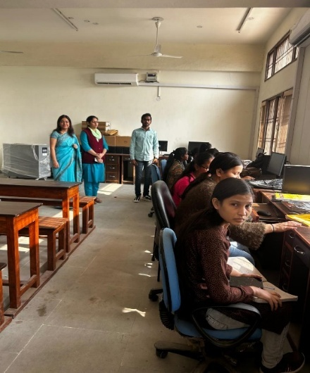
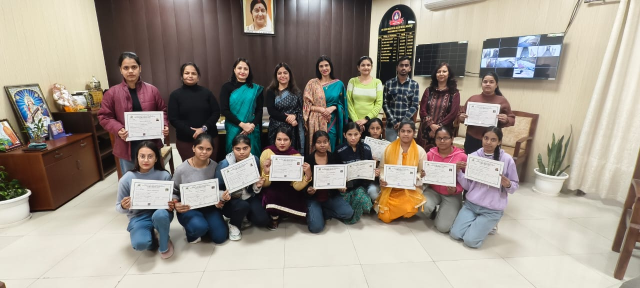
Principal and Faculty with the participants of 15 day Python certificate course
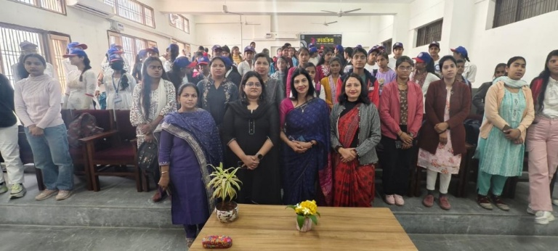
Department of computer science and NSS organised a expert talk by gynaecologist Dr. Rena Chawla from Suryodaya hospital in collaboration of Umar Ujala foundation on 21.2.2025

DEPARTMENT OF COMMERCE
- An Extension Lecture was organized On 14th Aug. 2025 On “Personality Development” & “Stress Management” Mr. Shubham Verma, Soft-Skill Trainer addressed 100 Girls Students.
- A One Day Workshop On Mutual Funds Was Organized On 6th Aug. 2024 Sh. Suryakant Sharma Ex-DGM, SBI addressed The Students on Savings & Investment Under Investment Awareness Programme.
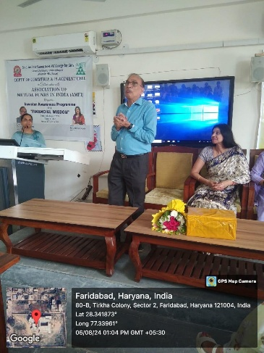
One day workshop on Mutual Funds

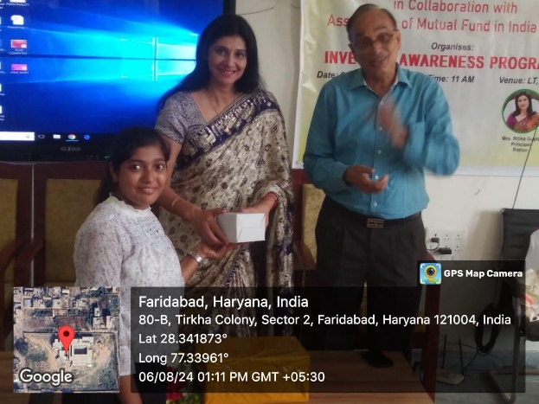

DEPARTMENT OF HINDI
- Hindi Divas was organized on 14 september 2024 in department of Hindi in which various activities were organized.
- College student Ashu and Deepanshi participated in district level Kavya Paath competition held at Pt. JLN College, Faridabad and secured 3rd position and consolation prize respectively.

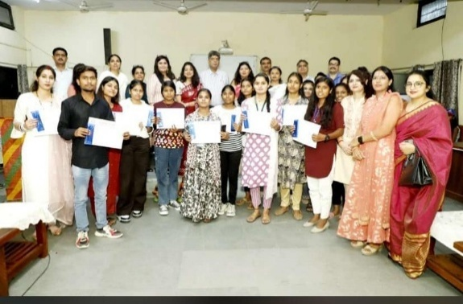
District level Kaavya Paath Pratiyogita on 14 September 2024

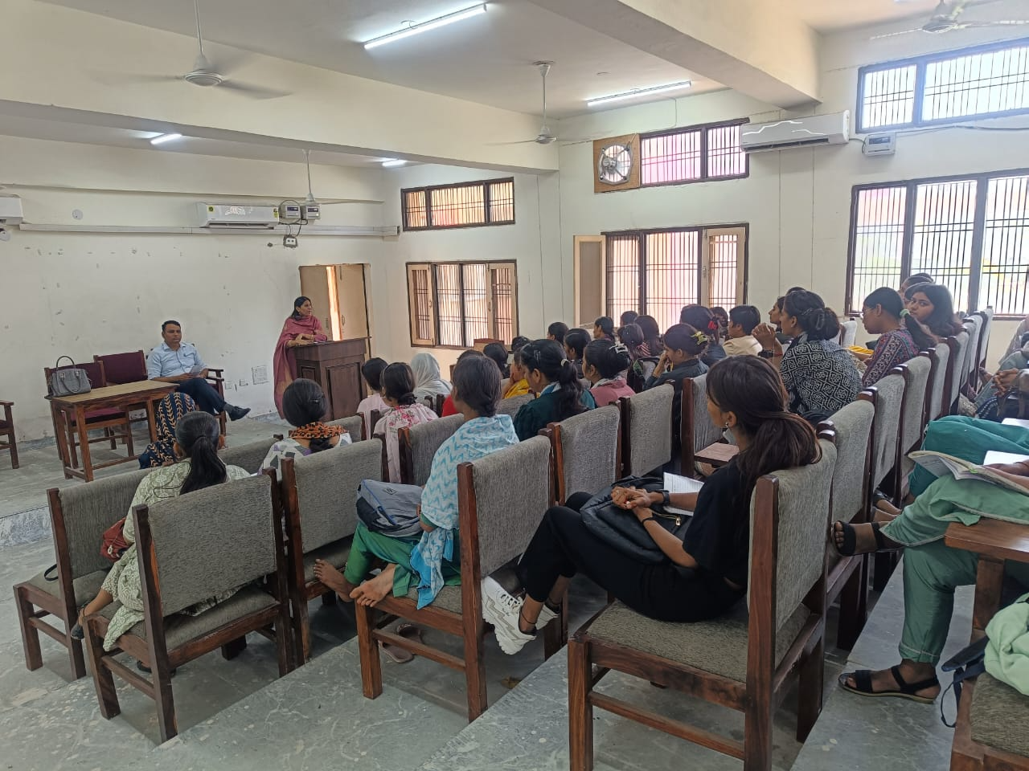
19 March 2025 expert lecture by Dr. Savita Adhana in Hindi department
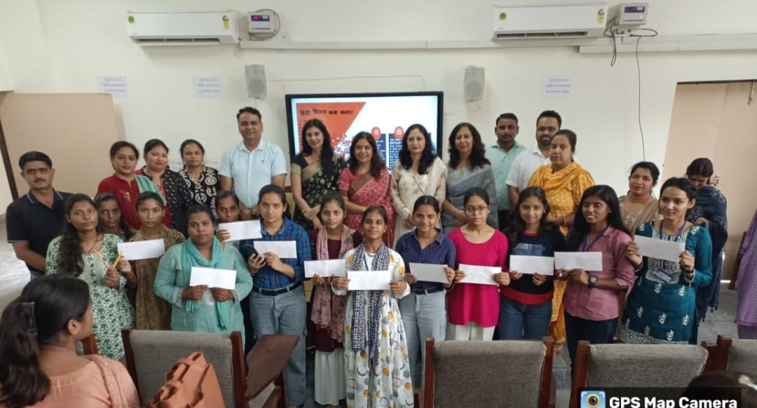
14 sept 2024, Hindi Divas prize distribution.

In collaboration with Red Cross cell of college and Amar Ujala Health Awareness Talk was organized by Specialists from Batra Heart and Multispecialist hospital
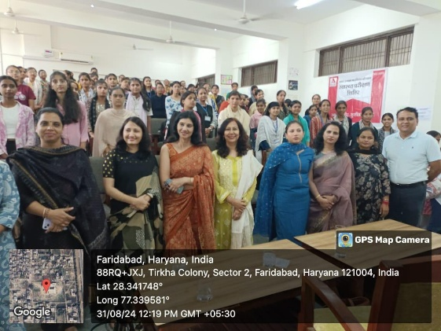
Health Awareness talk
DEPARTMENT OF ENGLISH
- District level essay writing competition organized on 9/01/2025.
- Students of the college participated in District level slogan writing competition on voters day organized at GC Tigaon on 25/01/2025.
- Speech competition organized during Vigilance Awareness Week under the aegis of the department of English sponsored by NTPC Faridabad. Gift vouchers awarded to students. 33 students of various streams participated.

DEPARTMENT OF PSYCHOLOGY
- Celebrated World Mental Health Day On 10 October 2024 in which like Poster Making Competition and Happiness Corner Making Competitions were organized. Besides these an Expert Lecture By Dr. Rajesh Nair. Prof., Public Health Foundation Of India ( PHFI ),
Gurugram was organized on the Topic, “ Effectively Dealing with Day To Day Stressors”.

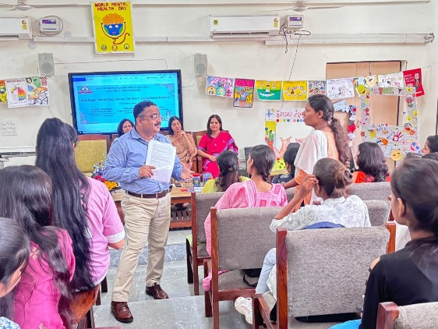
Expert Lecture by Dr. Rajesh Nair

- Students of Psychology participated and displayed their model “Unravelling Addiction Inside Recovery” in Inter District Science Exhibition On 5th Feb 2025 held at GCW , Faridabad. The Model was adjudged 1st. Kashish BA 2nd year student won Best Explainer award
- Students actively participated in State Level Science Exhibition On 21st And 22nd Feb 2025 at Pt Chiranjilal Sharma Government College, Karnal in subject Psychology and the Psychology Model secured 3rd Position.

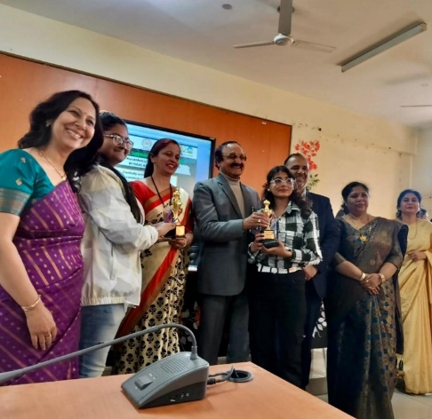
Kashish and Somya BA 2nd year students receiving trophy for securing III position in Psychology model at State level Science exhibition

DEPARTMENT OF POLITICAL SCIENCE
United Nations Day was celebrated on 24th October by organizing various competitions for students.
DEPARTMENT OF MATHEMATICS
1. Expert Lecture delivered by Dr. Mahabir Barak, Deptt. Of Mathematics, IGU Meerpur on 08-11-2024 on the topic “MATLAB Programming”.
2. Extension Lecture delivered by Dr. Kamal Kumar, Associate Professor, Deptt. Of Mathematics Pt. JLN Govt. College sec-16-A, Faridabad on 25-02-2025 on the topic “Applicable Mathematics”.

DEPARTMENT OF PHYSICS
- Pledge taken ceremony was organized on Occasion of “National Space Day” on 23th August 2024.
- Essay writing competition was organized on Occasion of “National Space Day” on 23th August 2024.
- Around 15 students of B.Sc participated in “National Level Online Space Quiz” on Occasion of “National Space Day” on 23th August 2024 organized by “Govt. College Mohna, Faridabad”.
- Six students from B.Sc participated in “District Level Sciences Quiz Competition” Organized by Pt. J.L.N. Govt. College, Faridabad on 28th August 2024.
- Science Essay writing competition was organized on 29th August 2024.
- Poster Making Competition was organized on 17th Sept. 2024 for celebrating “World Ozone Day”.
- Intra College Science Exhibition was held on 3rd Feb. 2025.
- A team of two students participated in Inter-District science Exhibition on 5th Feb. 2025 at GCW Faridabad.
- Three students of B.Sc Participated in Inter-College Quiz competition on 25th Feb. 2025 that was organized by K.L. Mehta Dayanand College for Women Faridabad for celebrating “National science Day”.

PERSONAL ACHIEVEMENT REPORT OF 2024-25
Dr. Sapna Nagpal
Professor
Deptt. of Computer Science

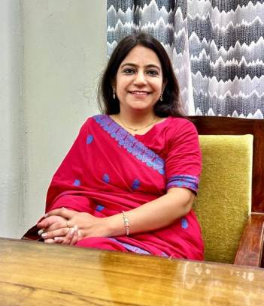
- Elected as Member of Academic Council of MDU Rohtak till February 2025.
- Member of UG Board of Studies, Department of Computer Science and Applications, MDU Rohtak.
- Worked as Administrative In-charge of the college from May 24, 2025 to June 26, 2025.
- Co- Convener of one Day Workshop on “Empowering Educators” successfully organized on February 8, 2025 at Smt. Sushma Swaraj Govt. College for Girls, Ballabgarh.
- Gem portal training attended on 6th june 2025 in online mode.
- Attended Two Days Training on “Virtual Training Programme on RTI for Government Colleges” on June 25 and 26, 2025 organised by Haryana Institute of Public Administration, Gurugram.

Dr. Sapna Sachdeva Nair
Associate professor
Deptt. Of psychology
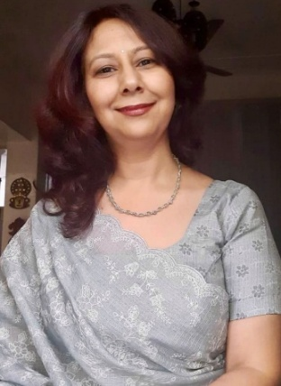

- Appointed as Member of UMC, M. D University, Rohtak for the second consecutive term for the session 2024-25.
- Awarded Certificate of Appreciation by M.D University, Rohtak for upliftment of cultural activities among students during Zonal/ Inter Zonal youth festivals.
- Co-Guiding a PhD on the topic , “ Mental Health in Adolecent survivors of child sexual abuse – A quasi experimental research with Rational emotive behaviour therapy”.
- Research paper, “International Perspectives and Challenges in implementation of life skills education among adolescents” published in Frontiers in Health Informatics, 13(3).
- Appointed as Clinical Psychologist in Victim Assistance Force under Victim Care and Support System (Healing the Victim) in Faridabad district by the Office of Chief Judicial Magistrate cum Secretary District Legal Services Authority, Faridabad in February 2025
- Mentored the students for Inter-district and State level science exhibition in which students secured 3rd position at State level and 1st position and Best Explainer Award at Inter District level.
- Convener of one day National Workshop on Empowering Educators” successfully organized on February 8, 2025 at Smt. Sushma Swaraj Govt. College for Girls, Ballabgarh.
- Contributed to the Anti- Drug Campaign of the Haryana Government by participating in Cyclothon 2.0 on Drug Free Haryana (5th April To 27th April 2025).
- Acted as Deputy Superintendent for NEET exam held for the 1st time in college on 4th May 2024.
- Performed Election duty as Sector Supervisor in Vidhan Sabha 2024 Haryana elections
- Successfully completed virtual training program by Haryana Institute of Public Administration Gurugram on RTI for Govt. colleges on June 25-26, 2005.

Dr. Usha Dahiya
Associate professor
Deptt. of Computer science
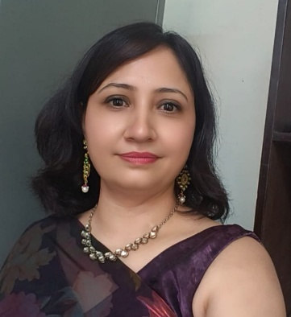

- Elected as Member of Court, M.D University, Rohtak for a period of 3 years w.e.f 01 March 2025.
- Co- Convener of One Day Workshop on “Empowering Educators” successfully organized on February 8, 2025 at Smt Sushma Swaraj Govt. College for Girls, Ballabgarh.
- Mentored the students for Inter-district Science Exhibition in which students secured 2nd position and Best Explainer Award.
- Presented a paper titled “Impact of Artificial Intelligence on decision making of Higher Eeducation System”in National seminar on 7-8 March 2025 in Satyug Darshan Institute of Engineering and Technology, Faridabad.
- Contributed to the Anti- Drug Campaign of the Haryana Government by participating in Cyclothone 2.0 on Drug Free Haryana (5th April To 27th April 2025).
- Successfully completed virtual training program by Haryana Institute of Public Administration Gurugram on RTI for Govt. colleges on June 25-26, 2005.
- GEM portal training attended on 6th June 2025 in online mode.
- Attended NEP 2020 orientation of sanitization programme organised by Mission Teacher Training Program on 16 September 2024 To 25 September 2024
- Attended a FDP organised by Apeejay Satya University on “ Educational Leadership and Effective Decision Making” conducted during 21 st to 25 th October , 2024.

Mrs. Ramanpreet Kaur
Assistant Professor
Deptt. Of Commerce
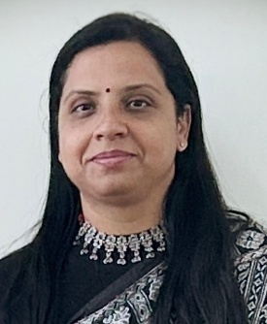

- Participated and presented paper titled,"Holistic Education- An approach to Child’s Development in the 21st Century” in one day multi- disciplinary National Seminar on NEP2020 held on 18th January2025 organised by Tau Devi Lal Govt. College for Women Murthal Haryana.
- Attended one day meeting on NEP2020: Indian Education held on 12 Jan2025 at Gurugram University.
- Participated as Organising Secretary in one day National Workshop on Empowering the Educators organised on 8th Feb 2025 under Research and Development Cell of our college.
- Participated in UGC Sponsored online STC on Research Methodology from 25 Nov-30th Nov 2024 and obtained A grade organised by MMTTC, JMI, New Delhi.

Dr. Richa Gupta
Assistant Prof.
Deptt. Of Political Science

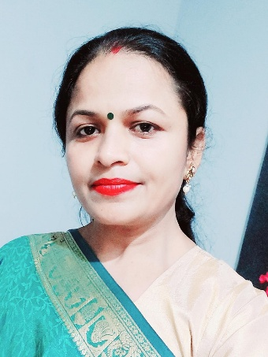

- Presented a paper in National Seminar on 7-8 march 2025 in Satyug Darshan Institute of Engineering and Technology, Faridabad titled “Impact of Artificial Intelligence on decision making of higher education student.”
- Contributed to the Anti- Drug Campaign of the Haryana Government by participating in Cyclothone 2.0 on Drug Free Haryana (5th April To 27th April 2025).
- Acted as Suprintendent of NEET exam held for the Ist time in college on 4th May 2024.
- Virtual training program on RTI for governor colleges on june 25 -26, 2025 by Haryana Institute of Public Administration Gurugram.
- Successfully completed NEP 2020 orientation of sanitization Programme organized by Mission Teacher Training program from 16 September 2024 to 25 September 2024
- Attended a FDP on “educational leadership and effective decision making” conducted during October 21 to 25 2024 Organized by Apeejay Satya university.
- Performed election duty on 5th oct 2024 as a sector supervisor.
- Paper setter for UG and PG courses in other universities.

Mr Chander Shekhar
Assistant Professor
Deptt. of Hindi
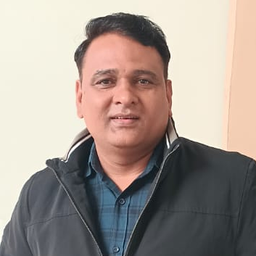

• Contributed to the Anti- Drug Campaign of the Haryana Government by participating in Cyclothone 2.0 on Drug Free Haryana (5th April To 27th April 2025).
• Successfully completed Virtual training program on RTI for Govt. colleges on June 25 -26, 2025 by Haryana institute of Public Administration Gurugram.
• Attended one day meeting on NEP 2020 on Indian Education held on 12 January 2025 at Gurugram University.
• Attended a FDP on “Educational leadership and effective decision making” conducted during October 21 to 25 2024 organised by Apeejay Satya University.
- Participated in one day National Workshop on Empowering the Educators organised on 8th Feb2025 under Research and Development Cell of the college.

Dr. Shivani Yadav
Assistant professor
Deptt. of Commerce
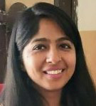

- Published a Research Paper entitled “What triggers people to buy green products?: Empirical evidence from an emerging market” in Business Strategy and Development in Wiley.
- Published a Research Paper entitled “How green marketing tools affect customers’ purchase behaviour: An Exploration from Indian Market” in International Journal of Management Practice in Inder science.
- Published a book chapter entitled “Marketing of Organic Produce” in Current Research in Food Science (Volume – 10), AkiNik Publications, New Delhi.
- Presented a Paper entitled “Barriers to Financial Inclusion in India (2004-2024): A Systematic Review” on 14-15 May 2025 in National Seminar on Social Inclusion and Sustainable Development of Himachal Pradesh: Looking Ahead sponsored by Indian Council of Social Science organised by Department of Economics, Government College Majheen, Kangra.
- Participated in “One Day National Workshop on Empowering Educators” on 8th February 2025 organised by Smt. Sushma Swaraj Government P.G. College for Girls, Ballabgarh, Faridabad sponsored by Directorate of Higher Education, Haryana.

Dr. Bhawna Kaushik
Assistant Professor
Deptt. of Computer Science
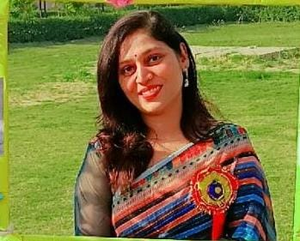

- Published a scopus indexed Book chapter "Role of artificial intelligence in healthcare" in book "cybermedics:Navigating AI and security in the medical field".
- Published a scopus indexed book chapter "leveraging association rule mining for effective query recommendation in search engines "in book "progressive computational intelligence, information technology and networking.
- Registered a UK design patent on "AI powered skin patch" on 4th september 2024
- Registered a UK design patent on "AI powered health monitoring Ring" on 26th september 2024
- Registered a UK design patent on "smart fitness Tracking Band" on 7th october 2024

Dr. Amol Singh
Assistant Professor
Deptt. Of English
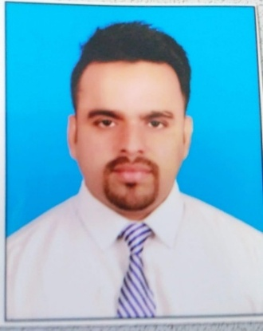

- Published a research paper titled “Subaltern Voices and Feminist Consciousness in Vijay Tendulkar’s Plays” in Volume I, Issue I (January 2025) of The Chitransh Academic and Research Journal of Multidisciplinary Research – an online, open-access, double-blind, peer-reviewed, and refereed international journal.
- Successfully completed Karmyogi Training organized by HIPA.
- Participated in a One-Day National Workshop on “Empowering Educators” organized at GCG Ballabgarh and sponsored by the Department of Higher Education, Haryana, on 8th February 2025.
- Completed a Refresher Course on “Law and Social Transformation” organized by MMTTC, University of Rajasthan, Jaipur, from 2nd to 14th December 2024, and obtained an A+ grade.
- Delivered an Extension Lecture under the Placement Cell at GC Tigaon on 19th March 2025 on the topic “Communication and Writing Skills.”
- Awarded the degree of Doctor of Philosophy (Ph.D.) in American Literature on 21st January 2025.

Dr. Dharmvir Singh Vashisth
Extension Lecturer
Deptt. Of Mathematics
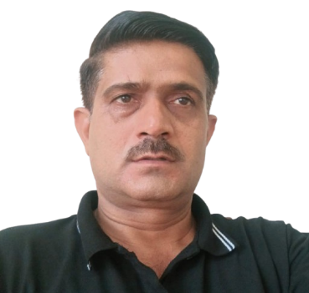

- Completed the NEP 2020 Orientation & Sensitization Program under Malaviya Mission Teacher Training Program (MM-TTP) of UGC Organized by Central University of Punjab, Bathinda from September 16-25, 2024.
- Completed One week online Faculty Development Program organized by Apeejay Stya University on “ Educational Leadership & Effective Decision Making” conducted during Oct 21-Oct 25, 2024.
- Completed training program “ MATLAB Onramp” on 01-12-2024 in online mode.
- Participated in one day National Workshop on “ Empowering Educators” organized by Research and Development Cell on 08-02-2025 in Smt. Sushma Swaraj Govt College for Girls , Ballabgarh
- As Convener successfully organized “Anti Drug Haryana-Cyclothon 2.0” rally “ Ek Cycle yatra Nasha Mukti ke Naam” an initiative by Govt. of Haryana on Drug Awareness (11-04-2025 )

Ms Divya
Deptt. Of Physics
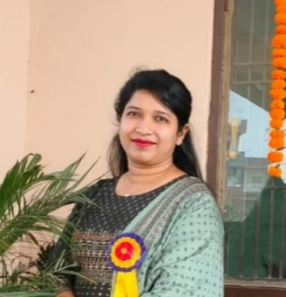

- Attended National Workshop on Empowering Educators held on 8th February 2025 at Smt Sushma Swaraj Govt. College for Girls, Ballabgarh.
- Mentored students to create a model for Inter District Science Exhibition held at GCW, Faridabad

GLIPSES

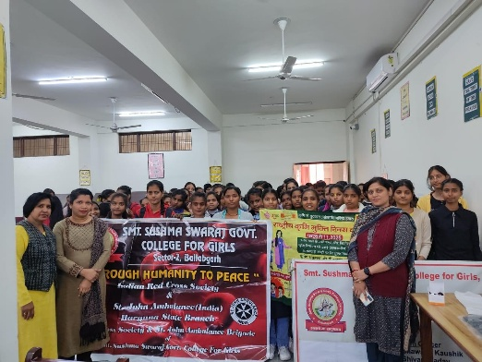
National Deworming day monitored on 11th Feb 2025
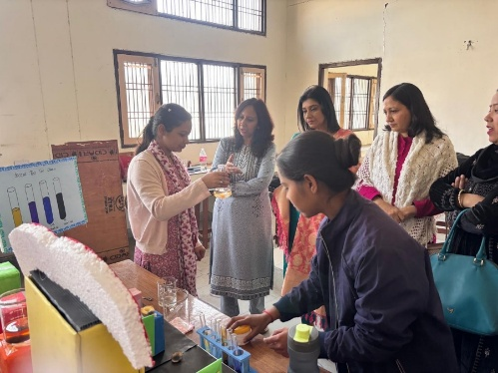
College level science exhibition on 3rd Feb 2025
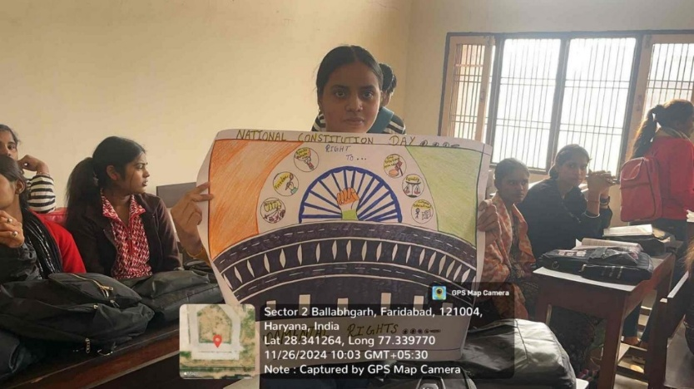
Celebration of constitution day.
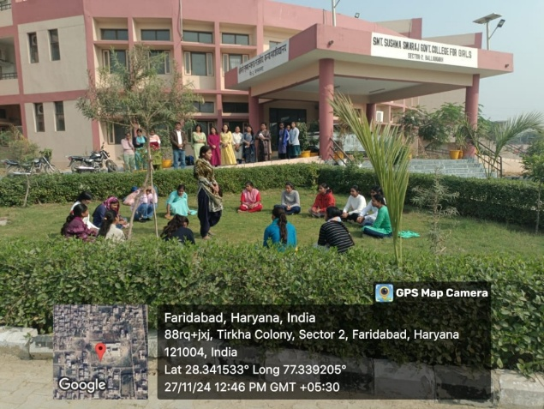
Nukkad Natak on Anti Drug Awareness
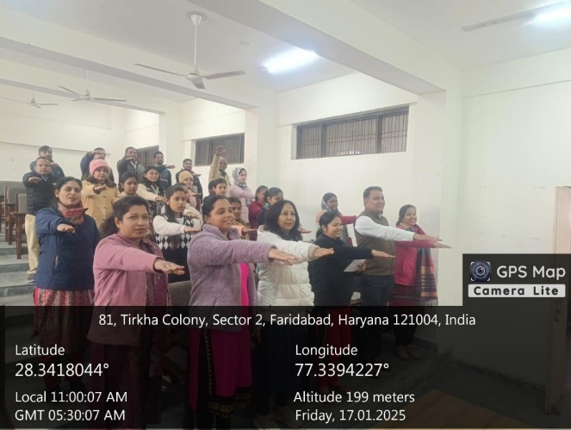
Preamble reading program on 17 January 2025
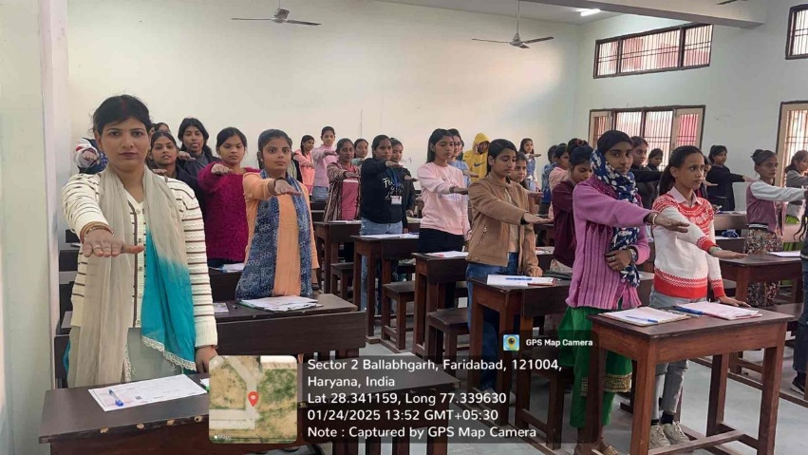
Oath taking under National Voters Day falling on 25/01/2025.
Students sought allegiance to the constitution of India 🇮🇳 and uphold its democratic values
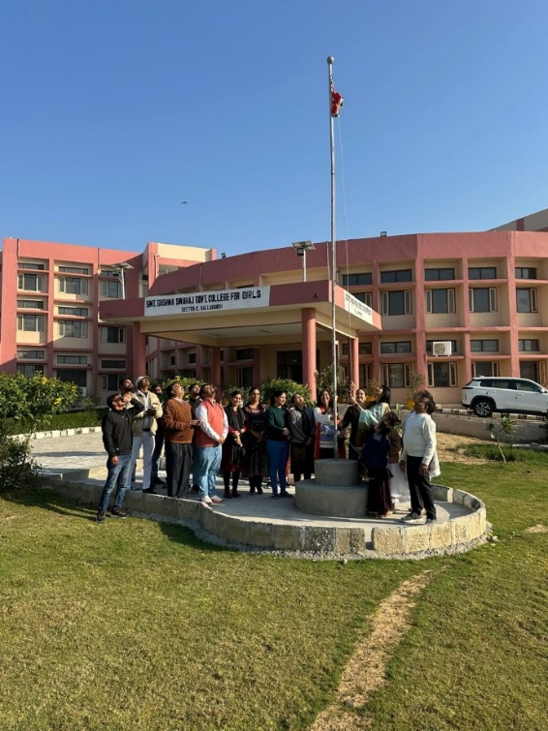
Celebrating republic day on 26th Jan 2025
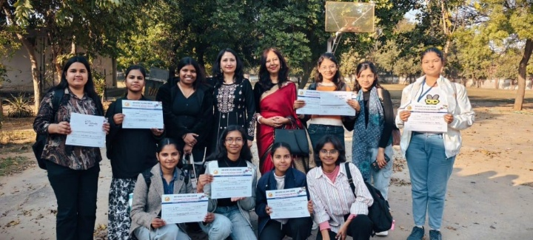
Winners of Inter district Science exhibition with Incharges Dr. Sapna Sachdeva Nair and Dr. Usha Dahiya

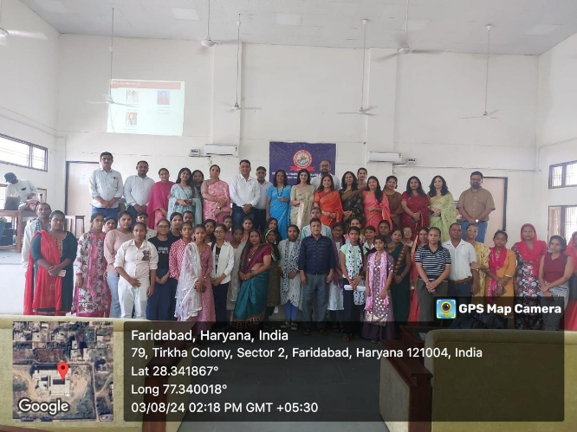
Orientation Programme

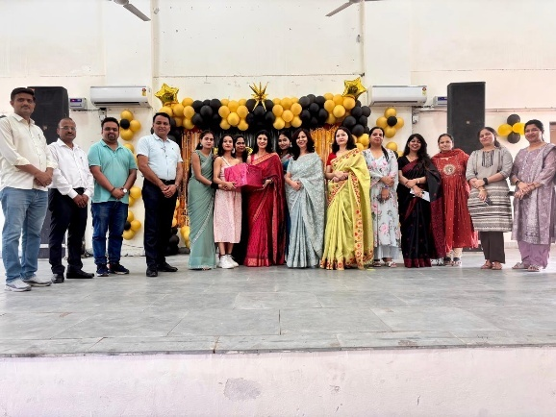
Farewell Party of BA final Year students

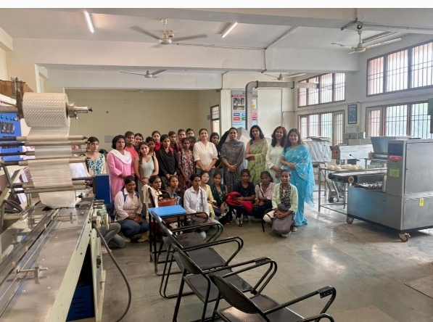
Industrial visit to NSIC

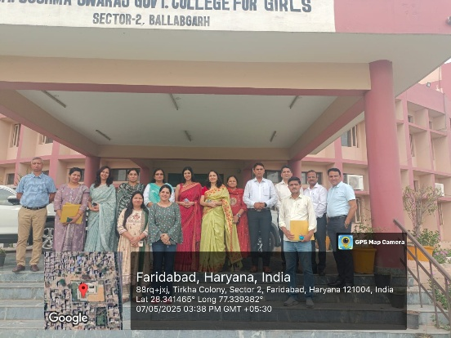
B.Sc( Medical and Non-Medical) Inspection team from M.D University Rohtak with Principal and faculty
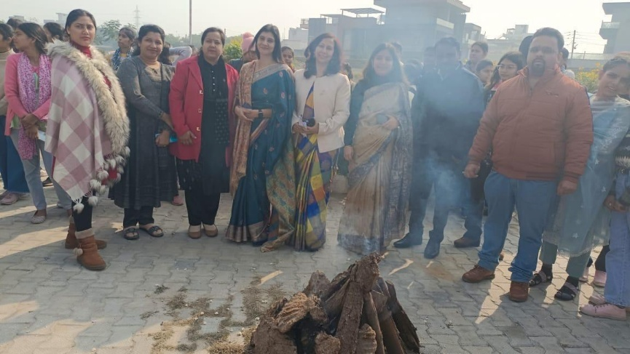
Lohri Celebration

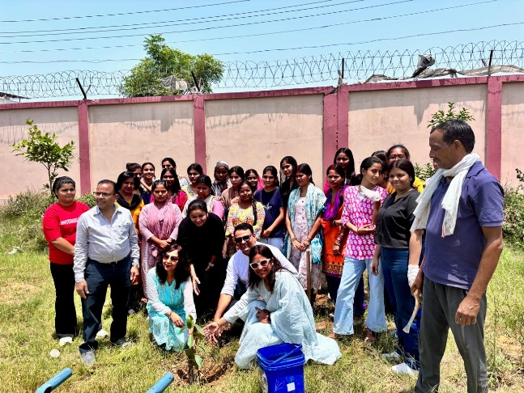
Tree Plantation in June
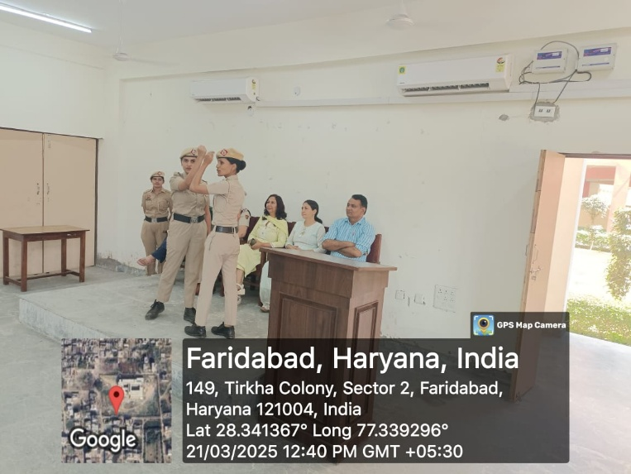
Self Defence training by Mahila Police Thana, Ballabgarh on 21.3.25
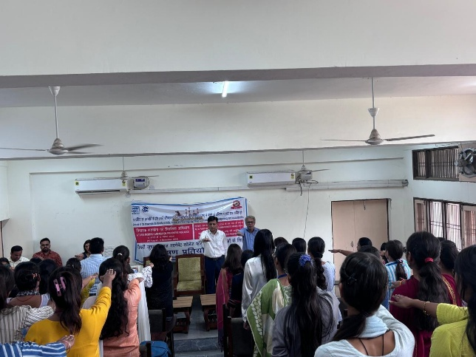
Vigilance week celebration

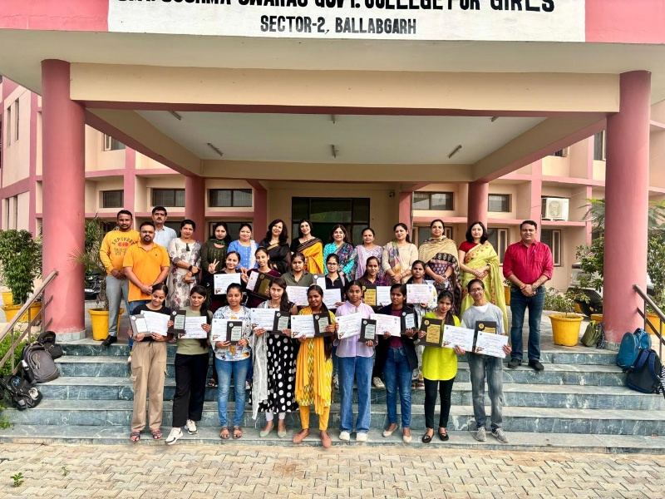
Prize winners of Zonal Youth Festival with Principal and Incharges

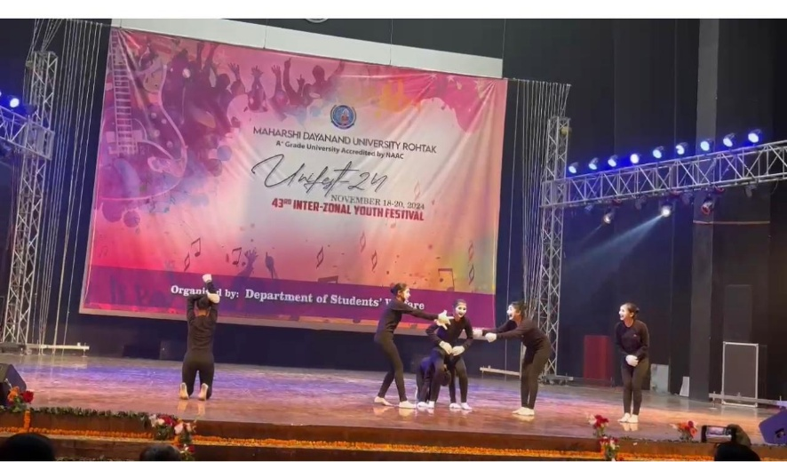
Students performing MIME at Interzonal Youth Festival, M.D. University Rohtak

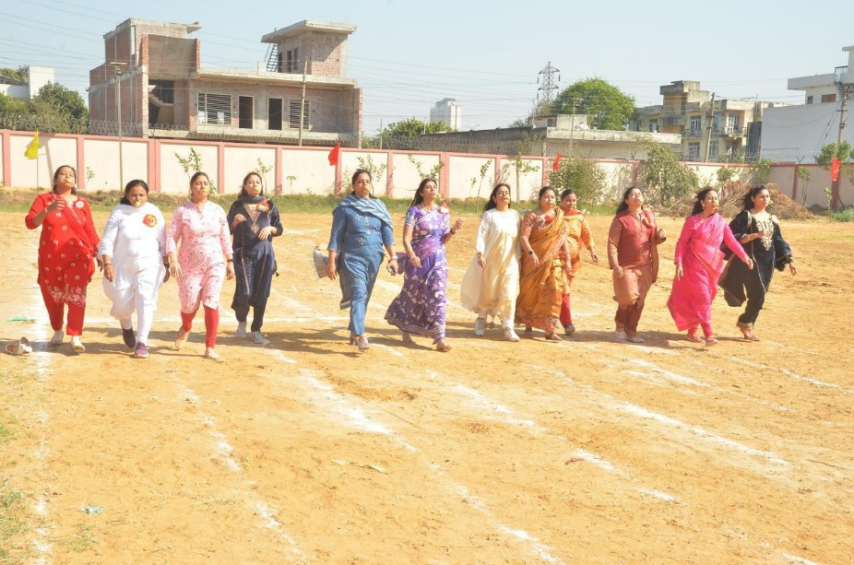
Lemon race for Staff on Sports day
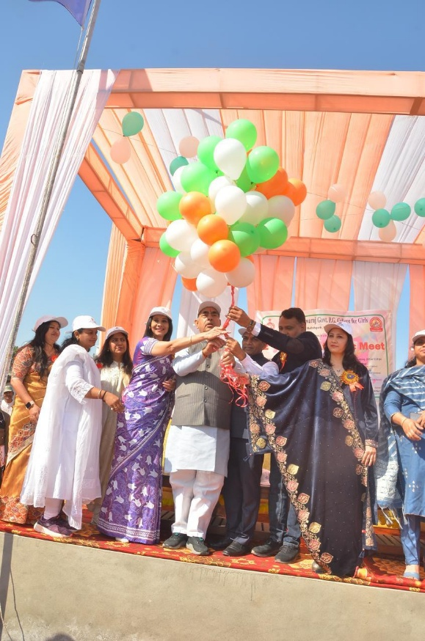
Inauguration ceremony of Sports day
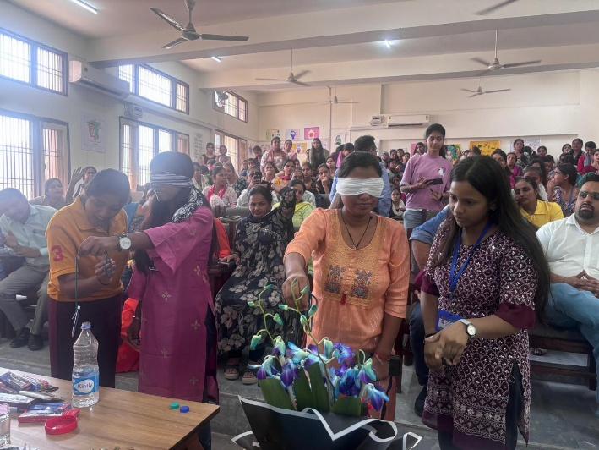
Students performing activity on World Mental Health Day on 10 October 2024

ANNUAL REPORT DRAFTING COMMITTEE
Dr. Sapna Sachdeva Nair (Convener), Associate Professor, Department of Psychology
Mrs. Ramanpreet, Assistant Professor, Department of Commerce
Sh. Chander Shekhar, Assistant Professor, Department of Hindi
Dr. Dharamvir Singh Vashistha, Extension lecturer, Department of Mathematics

